Thesis Proposal Kendall Slivka kms5585@psu.edu
Construction Management Robert Leicht
Student Life Building
Northampton Community College
Tannersville, Pa
Executive Summary

The Student Life Building is part of a three building campus for Northampton Community College. The design for the building began years ago when NCC purchased the large plot of land and hired D’Huy Engineering Inc. to help with operations. The project was then bid and construction began in spring 2012. The campus will be completed in 2014 and students will be able to enjoy the classrooms, library and enrollment center, and the student life building. The Student Life Building will house the campus’ gymnasium, fitness center, cafeteria, bookstore and meeting rooms. It also houses the central utilities plant for the campus.

As on any construction project there have been some constructability issues at the Student Life Building. As a spring thesis, I will focus on four of these issues, and research and analyze them. The issues that I have chosen to study cover a broad range of problems that could happen on any site. The fire suppression system is an area that I would like to redesign as a mechanical breadth topic. I think that there could be savings in an the choice of system dealing with both raw material costs and scheduling and labor costs. The structure of the building is another area I would like to study. The use of braced walls was initially a way to save money on steel while providing the same amount of support, however I feel it has compromised the aesthetics of the building. Another material that was chosen because of its economic reputation is the roofing material. The single ply roof membrane that is being used may be too thin for the harsh winters in Northeastern Pa, especially considering the roof pitch and the likelihood of ice collection.

Finally, I would like to study the foundation wall located along the break between the basement and the first floor slab. The constructability issues that have arisen because of this wall could be eased if it is designed as a retaining wall, however the problem is not that simple. I think that the issue truly stems from the delivery method- design-bid-build and the use of multiple prime contracts. As a research topic, I would like to study the effects of the delivery method on projects and project teams, and determine if there is a way to move the industry toward a delivery method involving early communication.

Table of Contents

Executive Summary _________________________________________ 2

Analysis Descriptions ________________________________________ 5

Bracing Walls _________________________________________ 5

Fire Suppression System ________________________________ 8

Roof Redesign_________________________________________ 10

Retaining Wall ________________________________________ 11

Conclusions _______________________________________________ 13

Appendix 1 - Breadth Studies__________________________________ 14

Appendix 2 - Data Collection Tool Draft__________________________ 18

The Student Life Building is a part of the three-part Monroe Campus that Northampton Community College is constructing in Tannersville, Pa. The construction process began in 2008 when the college decided to buy a 72-acre plot of land in the hope of expanding their current Monroe Campus. NCC contacted D’huy Engineering Inc. (DEI), a construction management firm, and the design process began. Together with DEI, the college hired architectural and structural consultants to being their design to life. Construction broke ground in spring 2012 and the final building will be completed by 2014.
The Student Life Building, the focus of my thesis project, will house the campus’ gymnasium, cafeteria, fitness center, bookstore, and meeting spaces for students and faculty. Its design is suitable for the various needs of the building and the renderings show it will have an aesthetic feel consistent with the existing campuses, and especially the other two buildings at Monroe.
There are many aspects to the Student Life Building, but four will be analyzed throughout the spring. The bracing wall system, fire suppression system, roof design, and the foundation wall will all pose different constructability, value engineering, and schedule issues and can be analyzed and discussed, and adapted.

Analysis Descriptions

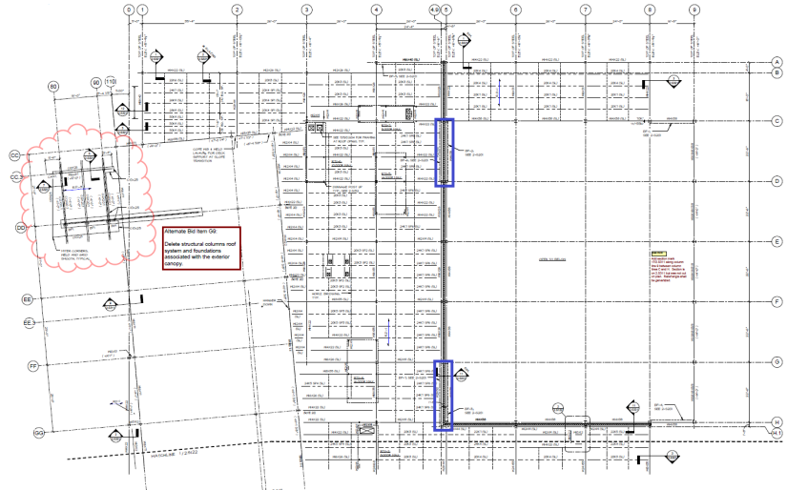
Bracing Walls

The design of the Monroe Campus has been created with the bottom line in mind. This budget consideration carried over into the steel column design. By utilizing bracing walls in multiple locations throughout the campus, the overall price of steel could stay below budget. The bracing lines described are shown in the drawings.
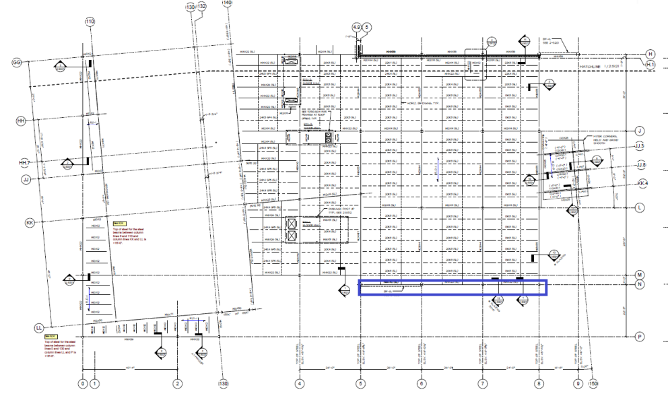
These bracing walls pose two potential problems. If there is ever a need to expand the buildings, the sections of braced wall could make it very difficult. Design would have to be done around the braced walls, which is not such an issue in the Student Life Building, where the largest section of braced wall separates the gymnasium from the rest of the structure, but in the other buildings on campus it may pose an even greater inconvenience.
The braced walls are not only an issue when expansion is considered; they also have an aesthetic drawback. The campus has been designed to have a very distinct aesthetic feel. With a mix of modern materials - glass curtain walls and metal sheathing and classic materials - brick and stone veneer, the campus will have both it’s own, new look and be a reference to the existing campuses. Braced walls would not normally impact the aesthetics of a building, however in the Student Life Building, and in other places on the new campus, the braced walls will align directly with glass curtain walls. This obstruction in the curtain wall will both hinder the view from inside the building, and be distracting to people viewing the building from the outside.

Speaking with members of the team, it was determined that the braced walls are not a necessity. The price of steel is dependent on its weight, and the design firm was originally told to stay within a budget. The braced system allows the larger interior columns to be eliminated, and therefore rings down the overall cost of steel. Once the project was bid, the team realized that they had overestimated a lot of prices, and underestimated how competitive the bidding market was. The current campus is being constructed at an overall cheaper price than the initial estimate. Larger interior steel columns would provide the same structural support as the braced wall and would still keep the project at a reasonable price.
The redesign is possible and has been discussed with the team onsite. Over the next semester it will be crucial to speak with structural and design consultants to edit the steel design of the building. The load calculations of the building will need to be determined and the columns dimensions can be inferred from there. By changing only the areas with braced walls, the project could stay within the initial budget, and potentially see a reduction in schedule.

Redesigning the structural system of the building would obviously be a structural breadth topic. It would be necessary to consult structural experts and delve into steel design requirements. This redesign would also incorporate the topics of value engineering and constructability. The team used the concept of value engineering to choose the braced walls, however I think that the look of the final product and its functionality have been somewhat compromised. Constructability is touched on because of the complexity of the braced walls versus larger columns. The larger columns and their additional weight may be harder to initially place, however time spent connecting the multiple beams of the braced walls surely affect the schedule and construction process.

Fire Suppression System

A central plant is a location within a multi building complex that provides heat, chilled water, and electricity to other buildings. The Student Life Building holds Monroe Campus’ central plant in its basement. This central plant has been designed to provide the necessary utilities for the other two buildings on campus, with room to expand. Monroe’s central plant has also been designed with energy efficiency in mind.
The fire suppression system of each building is a wet system. The system is supported with a 30,000-gallon water tank that sits behind the student life building. If activated, the tank will release and the water will feed whichever building needs it.
The Student Life Building has a fire suppression system that is somewhat different from the average. Instead of a single layer of sprinkler heads, in most areas of the building there are two layers. The shaded areas in the plan show these sections of the building.
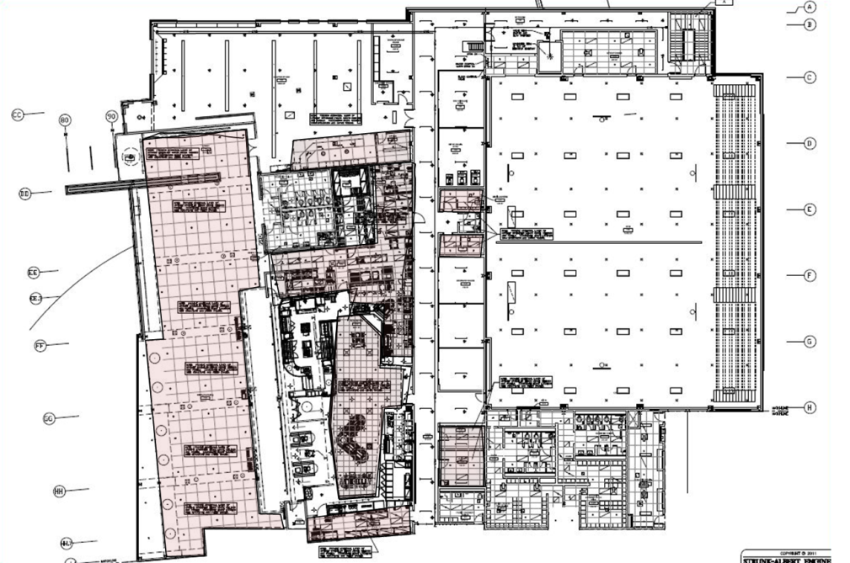

Initial research shows that the system was designed with dual sprinkler heads because of the hanging acoustical ceiling, which can also be seen in the attached plan. The hanging ceiling would slow heat from reaching the ceiling plenum, and delay response time to a set of sprinkler heads that was above. Likewise, if there were a fire within the ceiling plenum, the material would slow response time for sprinklers located below it. Discussions with the project team indicate that the dual sprinkler system is not the only possible solution. Use of a ceiling material that has a different fire rating, or eliminating the hanging ceiling could be considered. This would obviously change the aesthetics and acoustics of the spaces and would need to be studied further. Research into Northeastern Pa fire code, system cost estimates/comparisons, and interviewing fire system experts would also be a necessity.

An overhaul of The Student Life Building’s fire suppression system would also affect the other two buildings on campus, however using the building as a case study for the campus could be beneficial. This analysis would be a mechanical breadth topic for the spring semester. It also would have a strong value engineering connection because of the comparison of multiple systems. Finally, the constructability of the system would play a large part in whether or not it would the desired option. The labor and raw material cost of installing two sets of sprinkler heads was the initial reason I decided to analyze the system.

Roof Redesign
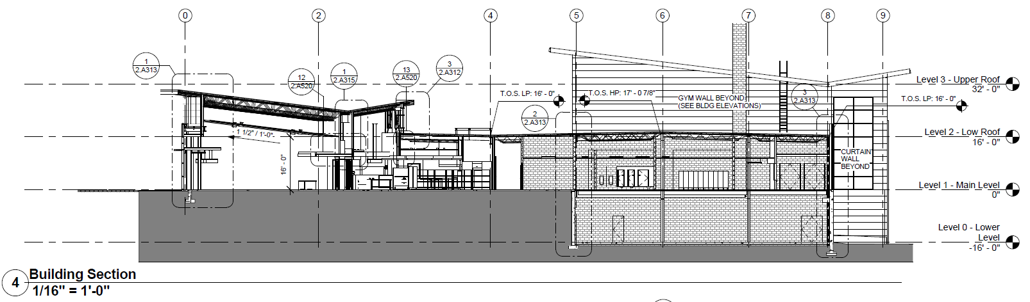

Northampton Community College chose a very distinct aesthetic design when approving the plans for the Monroe Campus. As discussed earlier, the mix of classic and modern materials are a reference to the sister campus’ and a way of setting the new campus apart. Strong linear patterns are one theme that is carried throughout the three buildings. The most prominent lines are the sloped roofs. Above each half of the building are roofs that slope like v’s indicating the two separate spaces. They act as two markers above the gymnasium above the cafeteria, pointing out where the action will take place.
Tannersville is located in Northeastern Pa, an area known for its harsh winters. Despite having drains in the area, snow and ice will undoubtedly build up in the crevices of the sloped roofs. The roof pitch is supported properly, however build up in these areas may cause failure. This would have to be an excessive buildup and maintenance teams would most likely recognize the problem well in advance.
The area for analysis of the roof would be the material chosen to construct it. As discussed, water and ice will inevitably run into the crevices, and the roofing material used is simply not strong enough to handle to conditions. The projects specifications call for a single ply TPO- a synthetic material made from plastic and rubber. This is a fairly new material that would be durable and cost effective, if not for the roofs slope and the likelihood of ice buildup. Instead, a built-up roofing system should be used. This system would ensure a waterproof finish, even if the outermost layer is damaged by ice.
Initial analysis of the roofing system was carried out through material research and statements from professionals. A deeper analysis could involve comparisons of similar roof structures in similar climates, and a detailed materials study. Failure studies would be a key research tool. The cost of different materials along with its installation procedures and average installation time would be factors as well. As it is proposed, the roof system will not cause constructability issues, however it will definitely cause maintenance issues for the owner.

Retaining Wall

The final analysis issue deals with a major constructability problem. While beginning work on the Student Life Building’s foundation, a setback occurred that significantly delayed progress. The foundation wall in column line 4.5-5 was designed to be just that, a foundation wall separating the basement area from the slab on grade floor of the gymnasium.
The original sequencing plan was to pour the wall, have the erection gang begin work of the first floor framing, and have the plumber come in and do his underground work around the steel team, then secure the foundation wall. There is a large amount of underground plumbing and mechanical work that needs to be completed next to the wall which can be seen in the drawings. The wall is not a retaining wall, and backfill could not occur until after all work was completed.
Complications arose when the plumber realized he would be working alongside the steel gang. The basement area is not that large and he had concerns about his equipment. The logistics of both sets of equipment had not been fully planned. The plumbing contractor also had safety concerns working alongside the erection gang.
Construction came to a standstill as the two contractors and the CM agency discussed different options. After days of discussion, the plumbing contractor was able to place his work prior to the steel team and construction continued.
The analysis area of this issue would be redesigning the wall as a retaining wall. The dimensions of the wall would need to be determined and the concrete design completed. Changing the design would cost more in the beginning, however scheduling afterward would be much easier.
Along with being a site-specific constructability issue, the retaining wall unveils a larger industry issue. The Monroe Campus was bid as a ‘Multiple Prime’ contract. The owner, Northampton Community College, secured help from a CM agency, DEI and design team to make initial building plans. Then, because the project has state education funding, Pennsylvania law dictates that a hard bid procedure be followed, and that multiple primes be used. The multiple prime contractors include a general contractor, plumbing contractor, electrical contractor, and an HVAC contractor. Each holds an equal contract with the owner, and therefore has equal say in site discussions.
Equality may seem appealing in such a team oriented industry, however the multiple prime contract method is known to greatly slow progress. Along with slower progress, Design-Bid-Build projects such as the Monroe Campus, often face budgeting, design, and communication issues. The systems these contractors are installing were designed without their input and expertise. Often, the minimum system requirements are given as a baseline for their work.
As an industry research topic, I would like to study the different project delivery methods and their effects on a project’s overall success. Design-Bid-Build has been the industry standard for decades and with the current technology, the industry stands to benefit greatly from a mass shift to Design-Build. Studying the Student Life Building alone, many of the constructability issues would be nonexistent with early and frequent communication between contractors. The early planning would also make it more likely for more companies to develop BIM business models.
In my research, I would like to delve into various case studies, poll industry professionals, see where the biggest setbacks in the industry are and determine what delivery methods could do in these situations. I would also like to research the laws in place protecting the Design-Bid-Build delivery method- like those in Pennsylvania, and determine what owners and construction companies can do to shift these regulations.

Conclusions

Throughout spring ‘13 I would like to analyze the various constructability issues described. The bracing walls provide a value engineering study along with a large structural breadth. The process of redesigning the interior columns to support the new load will need to be discussed and reviewed by a structural specialist. Redesigning the fire suppression system includes a value engineering study, constructability concerns, and a large mechanical breadth. It will include a large cost estimate along with rescheduling a new installation process. Fire code and materials will also need to be analyzed. The roof redesign is mainly a study in value engineering- comparing two different roof systems and materials. The lifespan of both can be studied in different regions and case studies will be a main source of information. Finally, the retaining wall will be an exercise in industry standards, concerns, and a prediction of where the industry can go.

Appendix 1 - Breadth Studies

Structural Breadth

Braced Wall Analysis

Goal: Perform a comparative analysis to determine if large interior columns can replace the braced walls in the designated column lines, and to compare their costs.
Process: To perform this analysis, I will need to contact a structural specialist. They would be able to approve- or disprove- any changes that I’m proposing. Specifically, these changes will relate to calculating the loading currently on the braced frames, and then sizing an appropriate column for that load. The calculations will be done using the ASTM standards and steel data. Professors Hannigan, Boothby, and my contacts at D’Huy Engineering Inc. and their structural consultant are the contacts that I will utilize to check my work.

Task Schedule:
- Make initial contacts with structural consultants; provide them with design and intent of analysis.
- Determine load paths and necessary capacity for columns in locations of the braced walls, contact consultants for approval.
- Determine the appropriate column sizes; have them approved by a structural consultant.
- Research steel pricing, both in existing design and the cost estimated to manufacture and install the larger columns.
- Compare existing and proposed costs, and determine whether the change is beneficial or not.

Mechanical Breadth

Fire Suppression System

Goal: Redesign the existing fire suppression system while adhering to all Pennsylvania fire code, and perform a comparative analysis on the existing and proposed systems.

Process: The Pennsylvania fire code will be an important research tool to determine the type of systems appropriate for the Student Life Building. Also, discussing the owners’ specifications with the CM agency contact. I will design a fire suppression system with one set of sprinkler heads. I will reach out to a mechanical consultant to approve my redesign of the system. Once my new system is designed, I will perform a cost comparison to the existing system, and the more beneficial system determined.

Task schedule:
- Contact the mechanical contractor through D’Huy, and determine a third party fire suppression consultant.
- Define an alternate system that could be used within a school that abides by Pennsylvania fire code, and approve it with consultant.
- Determine alternate ceiling plan if the hanging acoustic ceiling is the reason for the double system and perform a cost analysis of the new vs old ceiling.
- Design the system with locations of sprinkler heads and piping, and have it approved from a consultant.
- Perform a cost estimate on the new system, and an estimate of installation time/labor.
- Develop an overall comparison of the two systems and determine the most economic and easily constructible design.

Roof Redesign

Goal: To perform a comparative case study analysis of roofing systems in Northeastern Pa with a similar pitch/design and to determine a more economic roofing system. The economic impact is determined from a maintenance standpoint, rather than the initial roofing material and installation cost.

Process: In order to perform the case study, I will start researching projects in the Tannersville area and projects that DEI has completed in northeastern, Pa. comparing those roofing systems to that of the Student Life Building. Research on the current material will be done to determine its pros/cons and then I will need to research manufactures that create a similar, but stronger product. I will perform a cost analysis comparing labor and materials of both. The main source of firsthand advice/information on this topic will be DEI employees and their roofing contractors.

Task Schedule:
- Define owners’ needs in roofing membrane/ manufactures that will comply with the specs.
- Contact DEI project managers and poll/survey on roofing systems they have used. Use information in developing research for new system.
- Determine at least 2 alternative products that can be used as a roofing membrane.
- Find at least 3 projects with similar roof structure in areas with a similar climate, and determine their roofing system and maintenance problems or lack of problems.
- Create a cost estimate on the current system, labors and materials.
- Create cost estimates for the 2 alternate systems, with labor and materials considered and compare results.
- Create cost comparison of initial instillation and the proposed maintenance that would be necessary if failure occurred.

Industry Research

Retaining Wall

Goal: To determine the sizing and reinforcement design for the wall separating the slab on grade of the gymnasium and the basement utility plant that would ensure its use as a retaining wall. To use this constructability issue and begin a study on delivery methods and their effect on a projects overall success.

Process: Redesign of the wall will include concrete and rebar information that reflects the sizing material in CE397/AE404. Cost information can be collected from manufacturers and industry standards and the current design costs from the current budget. To perform the industry research I will need to create surveys for industry professionals, surveying 6-10 people in various positions. (owners/CM/GC/multiple primes) I will also research construction law regarding delivery methods and why they are specific in certain cases. Compiling the research and testimony I will make a statement on which delivery method should be used and how it is possible to change the current system.

Task Schedule:
- Create surveys for industry professionals and send them to contacts. Give a date for return.
- Obtain sizing information, size and reinforce the wall, seek approval from consultant.
- Obtain cost data for proposed retaining wall and existing wall, and compare the two.
- Obtain laws referencing delivery methods in Pa and surround states.
- Compile results of industry professionals; create statistics from their testimony.
- Develop a pro/con list from testimony on delivery methods, choose which will be sought after as standard.
- Develop a path for the industry to follow to push toward the desired delivery method.

Appendix 2 - Data Collection Tool Draft

Using an online survey;

- Choose your most preferred delivery method.
  - Design Build
  - Design Bid Build
  - Design at Risk
- Choose your most preferred contract type.
  - Lump Sum
  - Guaranteed Maximum Price
- In your career, approximately what percent of your projects have ben Design-Bid-Build?
  - 0%
  - 25%
  - 50%
  - 75%
- In your career, what percent of your projects have been CM at risk?
  - 0%
  - 25%
  - 50%
  - 75%
- In your career, what percent of your projects have used multiple prime contracts
  - 0%
  - 25%
  - 50%
  - 75%
- Approximately what percent of your projects have been design-build?
  - 0%
  - 25%
  - 50%
  - 75%
- Who do you feel benefits the most from a lump sum contract? Briefly explain.

- Who do you feel benefits the most from a GMP contract? Briefly explain.

- Please choose the answer that best describes your role in the construction industry. Also, how many years have you been in the industry?

