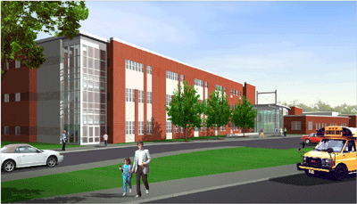
Thesis Proposal

Highland Elementary School
Carey L. Steckler
10 December 2004

In my continuing thesis research, I would like to focus on three areas. As a depth analysis, I will be exploring multiple prime delivery and public school projects. I will also work on two breadth analyses in the area of daylighting. One study will address the overall effects of maximizing window area and another will address the specific effects of additional window area on the building’s mechanical and electrical systems.

Analysis 1: Multiple Prime Delivery & Public School Projects

Issue
The focus of my in-depth research will be the effectiveness of multiple prime contracts in public school construction. Pennsylvania's Separation of Contracts Act requires that public school projects have least four separate contracts: (1) general; (2) plumbing; (3) heating, ventilating and air conditioning; and (4) electrical. The multiple prime system has been thought to deliver projects in a very timely and cost effective manner, a position widely disputed and rejected by many, including the Pennsylvania AIA.

Goal of Analysis
Determine specific advantages and disadvantages of the use of a multiple prime delivery method for the Highland Elementary School project.

Methodology

- Review literature & policies of other states.
- Gather information and study several projects from other states which have allowed alternative delivery methods.
- Interview/survey industry professionals experienced with multiple prime school projects. Sample survey questions:
- Summarize your experience with PA public school K-12 projects.
- What do you see as the benefits of multiple prime delivery…
to the School District? to the Contractors?
- What do you see as the drawbacks of multiple prime delivery…
to the School District? to the Contractors?
- What have you noticed to be specific problems with multiple prime projects?
- Apply pros/cons to Highland Elementary Project as case study.
- Draw conclusions based on information gathered, support with results of case study.

Analysis 2: Daylighting & Additional Window Area

Issue
In recent years, the positive effects of daylighting in educational spaces have been the topic of much research, and studies in favor of daylighting have been conducted by the Pennsylvania Governor's Green Government Council and the U.S. Department of Energy. It has been presented that students achieve higher test scores in classrooms that are daylit than in those that are not. Also supporting this position, daylighting has proven to significantly reduce energy consumption if used with proper electrical lighting equipment. See attached for exterior elevation and wall section.

Goal of Analysis
Determine effects of increasing typical Highland Elementary classroom window area to achieve maximum daylighting allowable by structural constraints.

Methodology

- Determine the maximum window area that can be achieved within constraints of structural system.
- Investigate benefits of additional daylighting on learning environment through literature review.
- Identify a few schools in Pennsylvania that have similarly maximized daylighting and note the outcome(s).
- Evaluate potential schedule impact.
- Assess impact on architecture of building.

Analysis 3: Effects of Added Window Area on Mechanical/Electrical Systems

Issue
As stated earlier, daylighting has proven to significantly reduce energy consumption if used with proper electrical lighting equipment. Therefore, lighting equipment for a room with increased daylighting may be different than for the same room with less window area. Additionally, increased window area will have an affect on the mechanical system necessary to cool and heat the space.

Goal of Analysis
Determine effects of increasing window area on Mechanical & Electrical systems. As designed, a unit ventilator with heating and cooling coils services each classroom in question. Typical classroom lighting is 48 LF of pendant fixtures with 32W T8 lamps.

Methodology

- Calculate/simulate additional heat and light added to typical classroom.
- Determine necessary lighting and HVAC equipment changes.
- Estimate cost impact.
- Estimate schedule impact.
Schematic Drawings of Proposed Changes (Analyses 2 & 3)

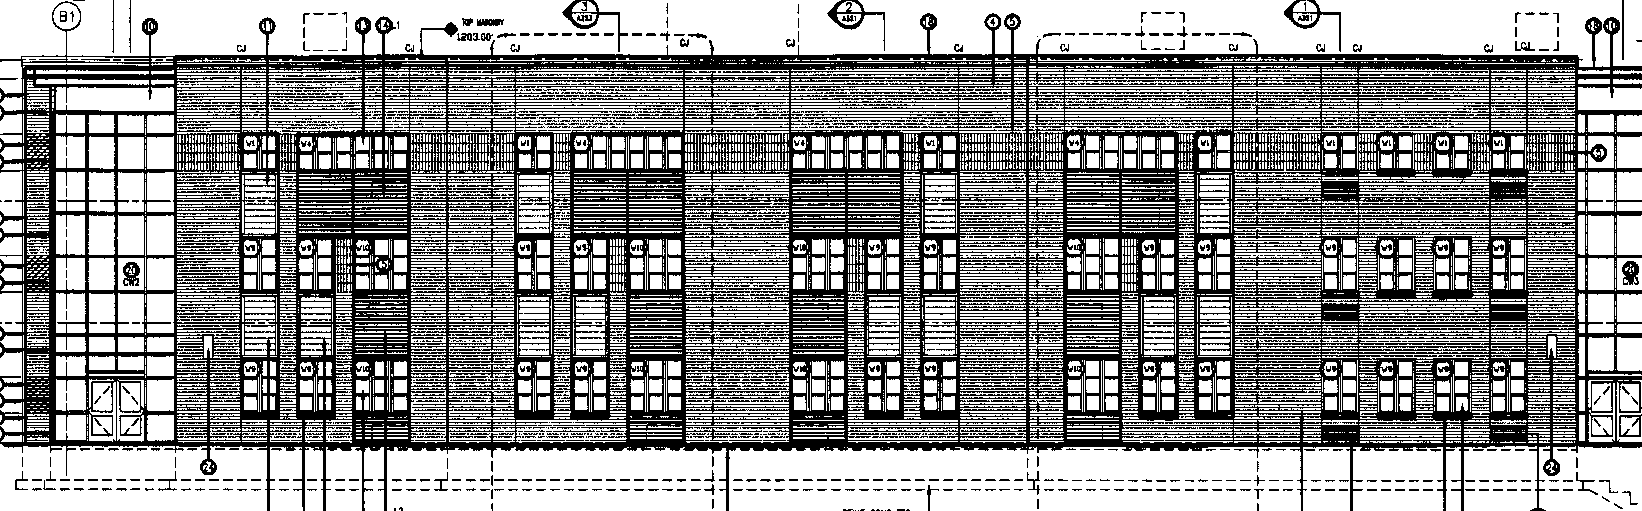
exterior b-wing elevation – as built

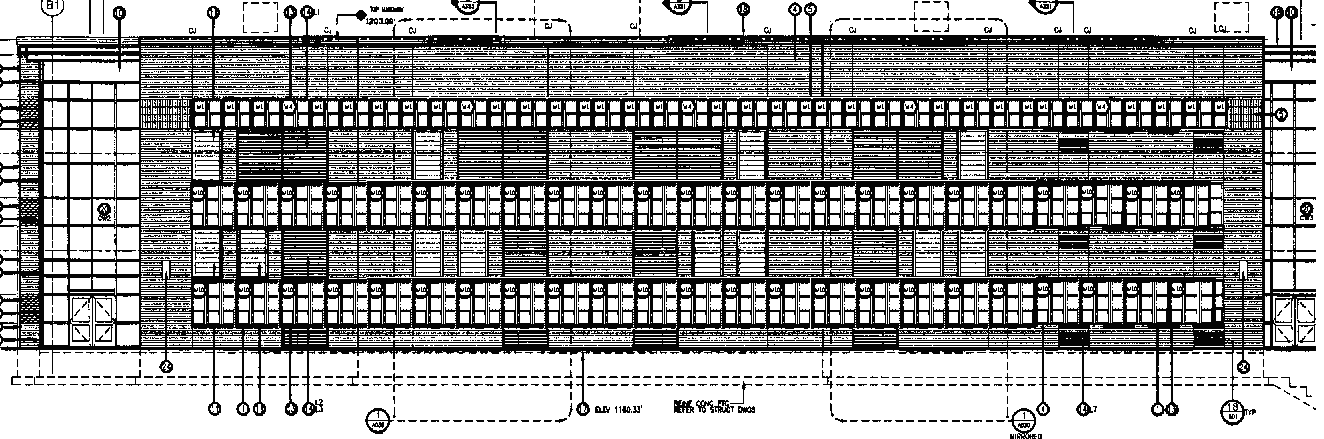
exterior elevation – with proposed changes

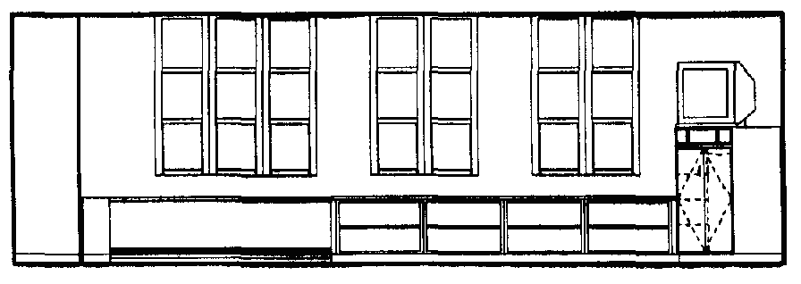
interior classroom elevation – as built

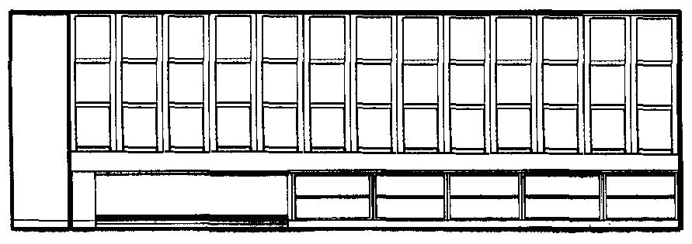
interior classroom elevation – with proposed changes
Weight Matrix

