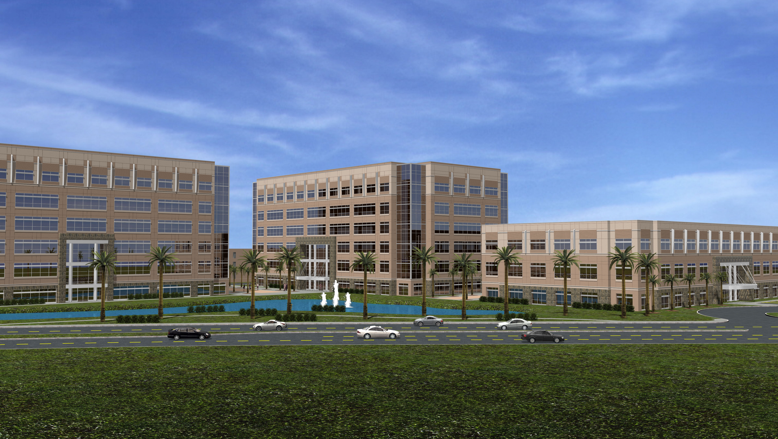

OFFICE BUILDING
Ontario, CA

Thesis Proposal
December 15, 2006
Re-design of the Lateral Force Resisting System

Maggie Machinsky
Structural Option
Advisor: Andres Lepage

Executive Summary

Building Description
This structure, Office Building B, is located in Ontario, California, and is part of a multi-facility complex which houses two additional buildings. All three buildings will primarily be used for office spaces. No specific construction dates have been established as of yet, however the owner would like to have the building constructed within the coming year.

Proposal
Because of the high cost of constructing moment connections, I plan on redesigning the lateral force resisting system in Office Building B with a reduction in the number of moment frames or with no moment frames at all.

Solution
To re-design this system I plan to analyze one system containing eccentrically braced frames, as opposed to concentrically braced frames with a reduced number of moment frames. The second solution I plan to analyze is a lateral force resisting system that utilizes only eccentrically braced frames.

Breadth Focuses
In addition to re-designing the lateral force resisting system I plan to make the building façade and structural system blast resistant, and improve the resistance to progressive collapse in the event of a blast. I will also analyze the constructability of re-designing the lateral farce resisting system through case studies, assembly estimate, and through quotes from vendors and suppliers.

Introduction & Building Background

This structure, Office Building B, is located in Ontario, California, and is part of a multi-facility complex which houses two additional buildings. All three buildings will primarily be used for office spaces. No specific construction dates have been established as of yet, however the owner would like to have the building constructed within the coming year.

Building B which climbs six stories, is approximately 168,000 square feet of floor space and has a story height of 16 feet from the ground floor to the second floor, and 14 feet for all other floors. The exterior façade is comprised of an appealing combination of alternating ribbons of adobe colored brick and glass.

This steel superstructure is supported by a foundation consisting of a 5” thick slab on grade with #4 reinforcing bars spaced at 15” O.C. in both directions, which is supported by spread footings and grade beams. Floors two through six are comprised of a composite floor system with 3.25” of lightweight concrete fill supported by a 3” metal deck and composite beams.

The second floor through the penthouse are typical with wide flange steel beams supporting a VERCO W3 Formlock 20 gauge metal deck. The metal deck is filled with 3-1/4” light weight concrete fill with #3 bars at 18” O.C. each way. The beams are designed to support a maximum span of 11’-0”, and typical bays are 38’ x 30’ and 33’-10” x 34’9”.

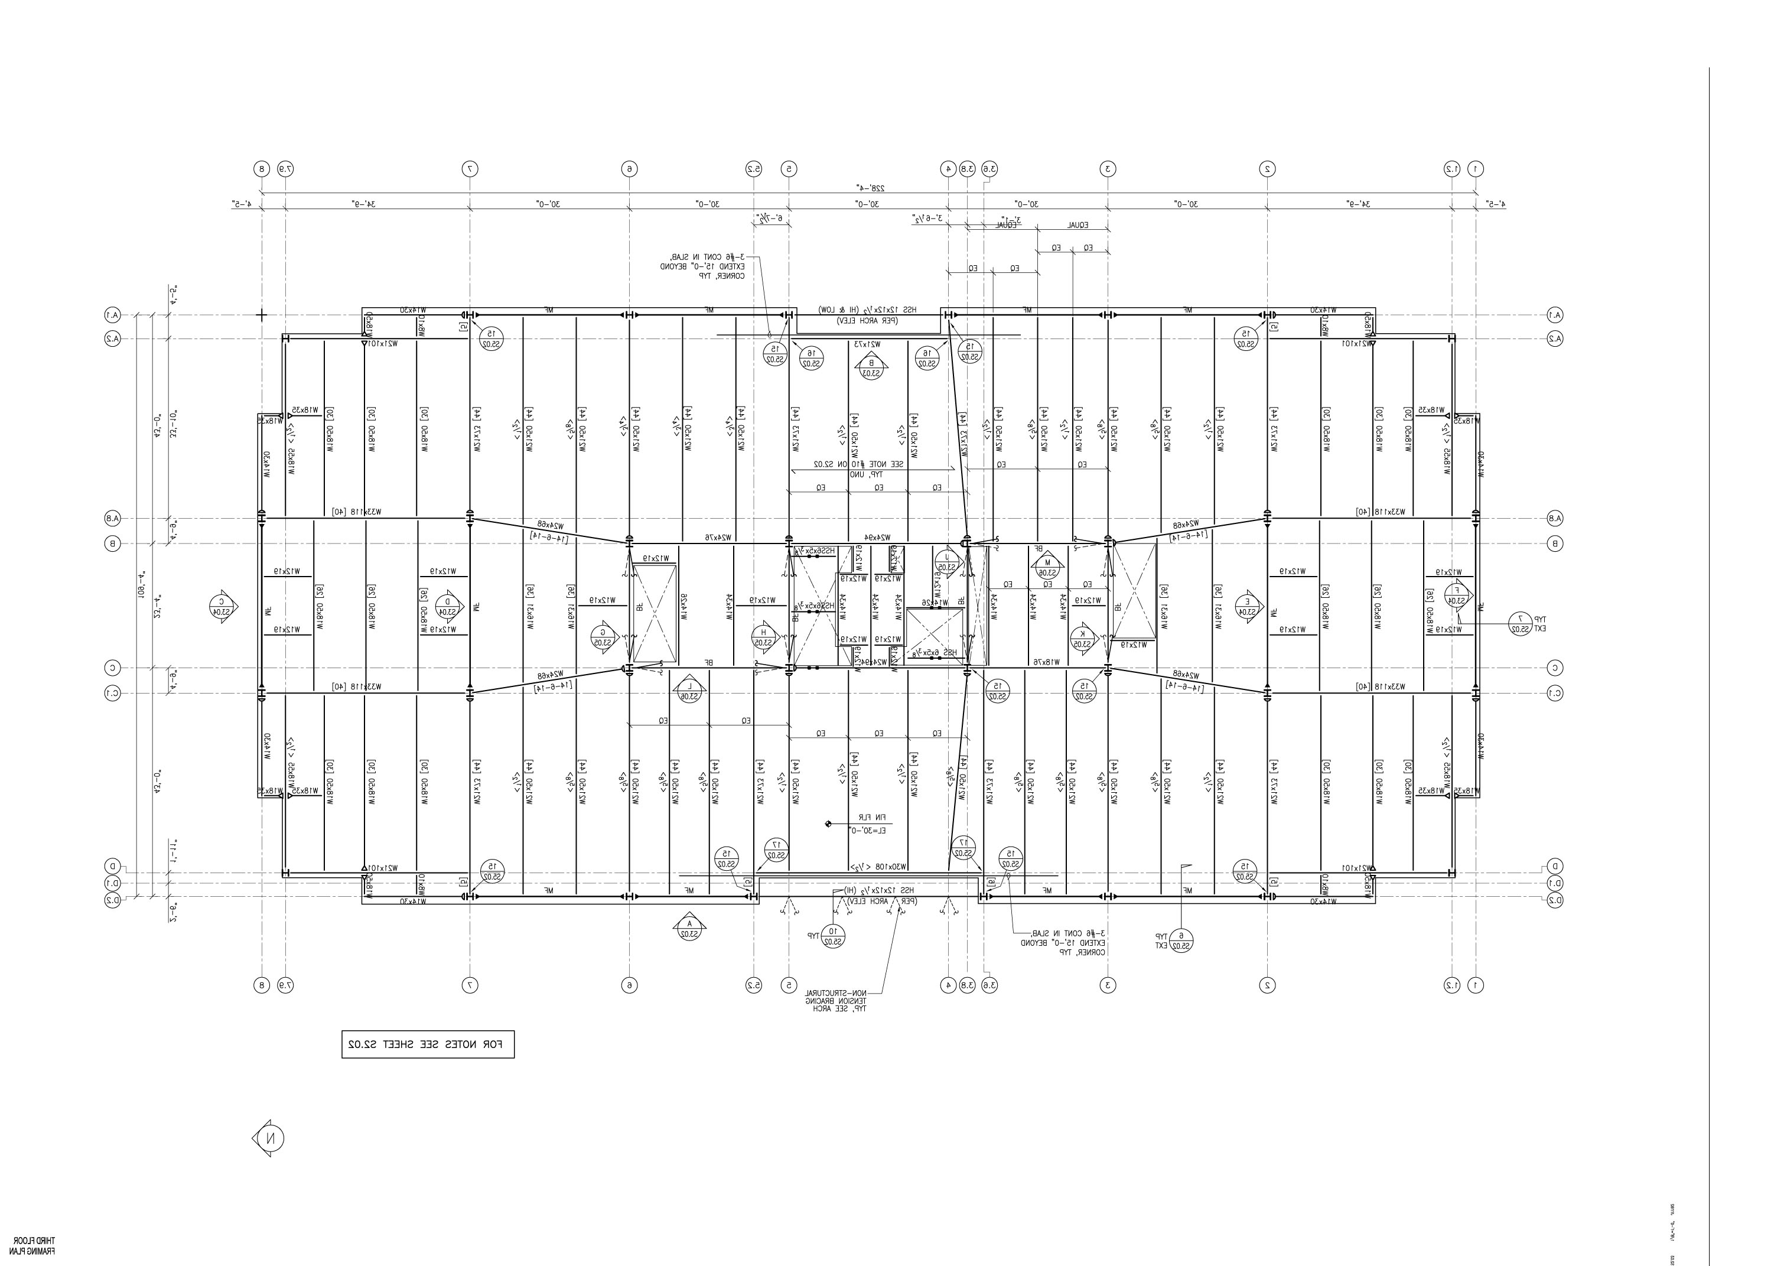

Wide flange ASTM A992 GR 50 steel columns support the structure and span 30.5’-0”, supporting about 2 stories and are connected by 4’-0” splices between floors. Most columns at the ground level are supported by the grade beams. All columns have base plates made of ASTM A572 GR. 50 steel, and are also part of the braced frame lateral system.

The lateral force resisting system in Office Building B consists of a network of specially braced frames and moment frames that combine to make up a dual system. This lateral System frames into the grade beams in order to counteract the large uplift force associated with this type of system. The moment frames are located mainly along the perimeter of the structural framing system with the exception of two on the interior, while the specially braced frames are placed solely on the interior near the center of the building in such places as elevator shafts.

The moment frames are made up of W shapes ranging in size from W36’s on the second floor to W27’s on the roof level. The braced frames were also constructed using W shapes. These braced frames were designed to distribute lateral forces through triangles formed by the members, much in the same fashion that a truss distributes forces, and range in size from W12x156 to W24x76.

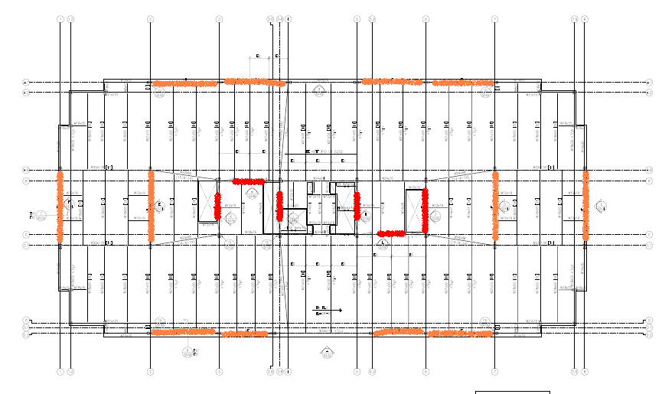

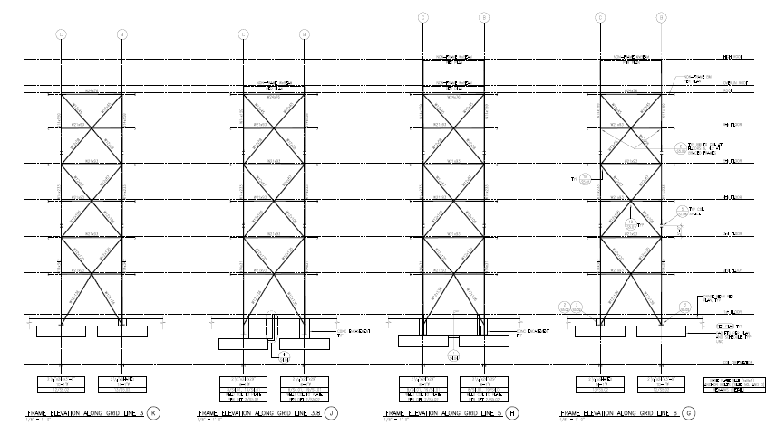

Problem Statement

The current lateral force resisting system, which is a dual system, brings into play a combination of concentrically braced frames and moment frames. Six braced frames and twelve moment frames make up the existing lateral force resisting system. According to ASCE 7-05, a dual system is not necessary unless the structure exceeds a total height of two hundred forty or more, thus making this design extremely conservative. In addition to this, the cost of construction to properly fabricate moment connections in the moment frames is very high. For these reasons I intend to propose an altered lateral force resisting system.

Problem Solution

Solution A:
The first solution that will be explored is one in which the number of moment frames will be reduced. By completely eliminating the moment frames that lie along the perimeter of the building and increasing the span on the existing interior moment fames from one bay to three bays, the number of moment connections will be reduced from twenty four to twelve. In addition, by arranging the moment frames and braced frames in this fashion, the system will no longer be classified as a dual system.

Solution B:
The second solution that I plan to examine is one that utilizes only braced frames. To successfully design this system, the floor plans must be thoroughly examined as additional braced frames will need to be placed in other areas of the building without interrupting circulation paths.

Solution Method

The new lateral force resisting system will be designed to resist wind and seismic loads, as well as control drift and counteract torsion using the methods outlined in ASCE 7-05. After the seismic and wind forces are calculated they will be entered into a computer aided building model program, such as RAM or ETabs which will calculate the forces dristibuted to each member. Finally, a sufficient design, based on these forces will be determined.
Breadth Focus

The first breadth study will be done on security design. This will entail the design of a blast resistant façade as well as a blast resistant structural system and improved resistance to progressive collapse in the case of a blast.

The other breadth study will consist of analyzing the constructability of re-designing the lateral force resisting system. This will include comparative case studies, assembly estimates, and actual quotes from the vendors and suppliers.

Tasks & Tools

Lateral Force Resisting system
- Calculate seismic and wind forces
  - Refer to ASCE 7-05 for detailed procedure on determining seismic forces.
  - Refer to ASCE 7-05 for detailed procedure on determining wind forces.
- Determine the loads that act on the members of the lateral system
  - Input the loads determined in previous steps into a computer modeling program.
  - Determine the worst case loading combination.
- Design the lateral force resisting system
a) Design the members according to AISC’s LRFD method.

Breadth Analyses
Security Design
- Consult Penn State Architectural Engineering faculty members on blast resistant design.
- Consult practicing designers with experience in blast resistant technology and design.
Constructability of re-design
- Contact manufacturers
- Perform in-depth cost analysis
- Compare results with existing design

Schedule

WEEK 1 | Determine all lateral and gravity loads
WEEK 2 | Start building computer model
WEEK 3 | Finish building computer model
WEEK 4 | Determine distribution of lateral forces
WEEK 5 | Research blast resistant technology
WEEK 6 | Research blast resistant technology
WEEK 7 | Design lateral system and blast resistant system
WEEK 8 | Design lateral system and blast resistant system
WEEK 9 | SPRING BREAK 2007 - SOUTH BEACH, FL
WEEK 10 | Design lateral system and blast resistant system
WEEK 11 | Perform in-depth cost analysis
WEEK 12 | Perform in-depth cost analysis
WEEK 13 | Prepare final presentation
WEEK 14 | Present thesis to faculty board

