Technical Assignment 3

A Report Investigating and Analyzing the
Existing Mechanical Conditions of
LA Fitness, West Oaks
Houston, Texas

Prepared For Dr. William Bahnfleth
The Pennsylvania State University

By
David J. Melfi
Mechanical Option
November 21, 2005

Table of Contents

Table of Contents.....................................................................................................1

Executive Summary.................................................................................................2

Design Objectives and Requirements......................................................................3

Energy Sources and Rates........................................................................................3

Factors Influencing Design Decisions.....................................................................4

Outdoor and Indoor Design Conditions...................................................................5

Design Ventilation Requirements............................................................................6

Design Heating and Cooling Loads.........................................................................7

Annual Energy Use..................................................................................................7

Schematic Drawings................................................................................................8

System Operation.....................................................................................................9

Tables of Major Equipment...................................................................................10

Critique of System.................................................................................................11

Executive Summary

This report is an analysis of the mechanical systems to be installed at the West Oaks location of LA Fitness. This building is currently under construction and will be completed in December of 2005. LA Fitness owns a number of these fitness facilities across the country and continues to expand each year with new building projects.

The owner, LA Fitness International, has some preconceived notions about which type of mechanical systems are currently in place at other sites and wishes for the buildings to be as standard as possible for ease of maintenance. This can result in a solution that is not always the best ultimate design for a specific site.

This analysis shows that although the basic design requirements such as indoor temperature and humidity control have been met, there are some shortcomings that need to be addressed. The prevailing issues are the uneven ventilation distribution and the potential for more energy efficient approaches.

There are many possibilities available to help this building save energy. Some of these options include the use of a chilled water plant instead of rooftop units, the analysis of new pool design methods, the use energy recovery from return air, and the potential use of combined heat and power systems.

Design Objectives and Requirements:

LA Fitness is an organization that takes great pride in being on the cutting edge of exercise facilities. The company was originally established in Southern California and has branched out greatly from there. The owners demand a very comfortable indoor climate and request standardization of their systems between buildings, which presented a challenge to mechanical designers of this project. It would be a terrible experience to have to work out in a sports club in Houston with terrible humidity control and high temperatures.

Each LA Fitness around the country offers different activities for their users to enjoy.
This location of LA Fitness has diverse spaces including cardio rooms, basketball and racquetball courts, offices, juice bars, a child care center, locker rooms, and a pool. The mechanical designers had to work with this variety of spaces as well as the high levels of humidity already inherent with designing in Houston. Adding to the heat gain inside of the building is approximately 70 electrically powered machines for cardiovascular exercise.

Energy Sources and Rates:

The energy sources for the site are electricity and natural gas. As the building is still being constructed, the designers could not confirm energy rates that will be used. Listed below are energy rates found for commercial buildings in the Houston area. It is assumed that the actual rates used will not vary much from those listed here.

Electricity:
Demand: $8/kW
Energy Charge: $0.078/kWh

Natural Gas:
Energy Charge: $8.43/1000ft³ = $8.03/MMBtu

Spark Gap Analysis:
$0.078/kilowatt-hour = $22.86/MMBtu
Spark Gap = $22.86 - $8.03

Spark Gap = $14.83

Factors Influencing Design Decisions:

Though there were no rebates or cost factors that initially influenced the design process, there were some other factors that did come into play as the project developed.

LA Fitness is a company with over 135 clubs located in ten different states. Associated with this level of franchising comes the request from the owners to make the buildings as standardized as possible for ease of expansion. An inherent problem with this approach to construction is the inability to meet design conditions of varying climates. For example, the owner would not consider the possibility of a chilled water plant to serve the building because of the existing conditions that were “good enough” for the other sites. However, Houston has very high humidity levels. This results in latent loads that are typically too high to serve with direct expansion equipment alone.

Sometimes there are factors that occur that could not be accounted for in the original design documents. When hurricane Katrina hit New Orleans there was a massive need for construction and rebuilding. Other cities along the gulf coast suffered because this event drove many construction workers out of cities to places where there was going to be more work for them. In Houston, several projects were delayed or cancelled as a direct result of this disaster. The construction companies that were still in the area were able to charge much higher prices for their work. This became a design factor in the sense that if the same project were to be bid on now at the same location, the construction cost would be higher and there would be more value engineering throughout the process.

Outdoor and Indoor Design Conditions

Outdoor Design Conditions:

These conditions were taken from the 2005 ASHRAE Handbook of Fundamentals for the 99.6% and 0.4% conditions.

Location: Houston, TX
Elevation: 108 ft

Summer Conditions:

Design Dry Bulb: 96.9ºF
Design Wet Bulb: 80.1ºF

Winter Conditions:

Design Dry Bulb: 27.7ºF

Indoor Design Conditions:

The following conditions listed in Table-1 have been obtained from the mechanical design documents provided by Advanced Technologies, Incorporated.

Area Served | Unit | Occupied Setpoint (ºF/RH) | Unoccupied Setpoint (ºF/RH)
Entry | RTU-1 | 75/NA | 84/65%
Kid's Club | RTU-2 | 75/NA | 84/65%
Pool | RTU-3 | 80/55% | 84/65%
Lockers | RTU-4 | 76/55% | 84/65%
Basketball | RTU-5 | 72/55% | 84/65%
Free Weights | RTU-6 | 72/55% | 84/65%
Aerobics | RTU-7 | 72/55% | 84/65%
Racquetball | RTU-8 | 72/55% | 84/65%
Cardio | RTU-9 | 72/55% | 84/65%
Cardio | RTU-10 | 72/55% | 84/65%
Interior | RTU-11 | 72/55% | 84/65%
Spinning | RTU-12 | 72/55% | 84/65%
Mezzanine | RTU-13 | 72/55% | 84/65%
Table-1: Setpoints for the Spaces of LA Fitness, West Oaks

Design Ventilation Requirements:

Table-2 below shows a comparison of the ventilation air required from Standard 62.1n and the actual outside air as it is found in the design documents. Although the total outdoor air for the entire building came close to meeting the ASHRAE standard, the unit by unit breakdown shows that the ventilation air needs to be better distributed.

 | 62.1n OA | Actual Design OA | Total Airflow Used | Design %OA | 62.1n %OA
RTU-1 | 154 | 500 | 5000 | 10.0 | 3.1
RTU-2 | 1188 | 700 | 5000 | 14.0 | 23.8
RTU-3 | 3620 | 3500 | 10500 | 33.3 | 34.5
RTU-4 | 807 | 3350 | 8300 | 40.4 | 9.7
RTU-5 | 629 | 750 | 7500 | 10.0 | 8.4
RTU-6 | 1368 | 750 | 6000 | 12.5 | 22.8
RTU-7 | 1419 | 1000 | 10000 | 10.0 | 14.2
RTU-8 | 651 | 500 | 4000 | 12.5 | 16.3
RTU-9 | 2420 | 1675 | 6600 | 25.4 | 36.7
RTU-10 | 2420 | 1675 | 6600 | 25.4 | 36.7
RTU-11 | 1049 | 750 | 5500 | 13.6 | 19.1
RTU-12 | 524.5 | 500 | 3500 | 14.3 | 15.0
RTU-13 | 1380 | 750 | 5900 | 12.7 | 23.4
Entire Building | 17628 | 16400 | 84400 | 19.4 | 20.9
Table-2: Design and Actual Ventilation Rates for LA Fitness, West Oaks

Design Heating and Cooling Loads

The designer for this building did not include the cooling and heating design loads into the design documents. However, after using Trane’s TRACE energy simulation software the resulting design loads were found.

Design Heating Load: 970,475 Btu/hr

Design Cooling Load: 230 tons

Annual Energy Use:

As a result of the building not yet being constructed, the loads had to be simulated through a computer model. Provided in Table-3 below is an estimate of the energy consumption for a typical year in Houston.

 | Elect Cons. (kWh) | Energy |  | (kBtu/yr)
Primary heating |  | 0.27 | % | 124.27
Cooling Compressor | 584,809.44 | 46.38 | % | 59,884.62
Tower/Cond Fans | 77,836.40 | 6.17 | % | 7,970.47
Other CLG Accessories | 10,722.31 | 0.85 | % | 1,097.97
Cooling Subtotal.... | 673,368.12 | 53.40 | % | 68,953.05
Supply Fans | 41,252.03 | 3.27 | % | 4,224.22
Aux Subtotal.... | 41,252.03 | 3.27 | % | 4,224.22
Lighting | 542,872.94 | 43.05 | % | 55,590.32
Totals** | 1,257,493.00 | 100.00 | % | 128,891.85
Table-3: Annual Energy Use Breakdown for LA Fitness, West Oaks

Schematic Drawings

Gas Water Heater Schematic:

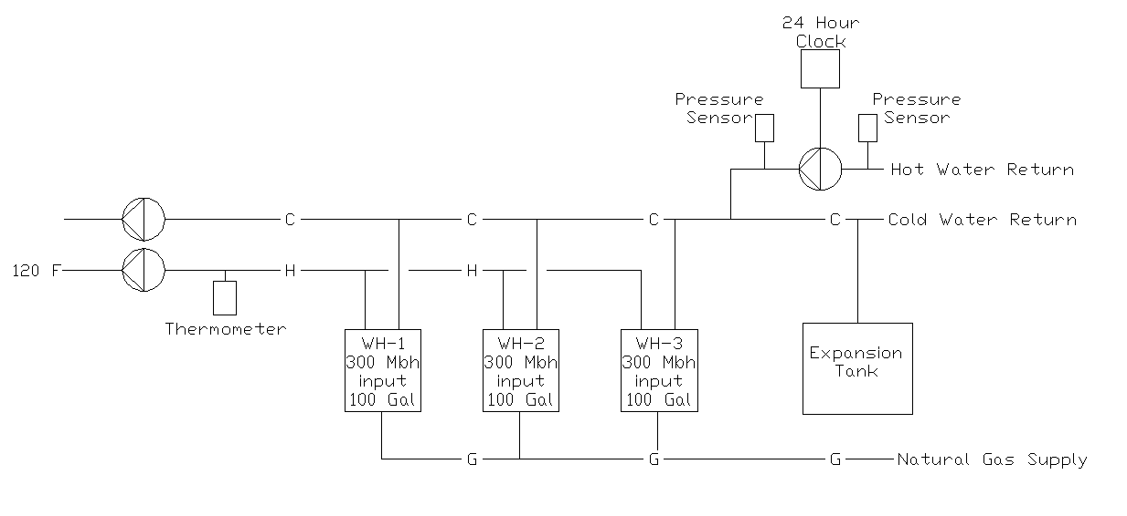

Figure-1: Schematic Drawing of Gas Water Heating Used in LA Fitness, West Oaks

Rooftop Unit Schematic:

Figure-1: Schematic Drawing of Rooftop Units and Controls Used in LA Fitness, West Oaks

System Operation

Start-Up:
Rooftop unit start-up sequentially; they are staggered by 2 minutes during the morning start-up procedure. The order is RTU-9, RTU-10, RTU-6, RTU-1, RTU-2, RTU-11, RTU-13, RTU-7, RTU-12, RTU-5, RTU-8, RTU-4, and then RTU-3. This start up was influenced by the air balances between adjacent spaces. For example, RTU-3 serves a pool area and must be kept slightly negative; this unit turns on last to ensure this even during start-up.

Every rooftop unit has evaporator fans built into it. These fans are to operate continuously during the occupied hours for the building.

Cooling Mode:

During unit fan operation, if the temperature in the space increases above 2ºF above the temperature setpoint (72ºF), one stage of cooling shall be enabled. Upon further rise in space temperature of 1ºF, the second stage of cooling will be enabled. If humidity rises 5% over the humidity setpoint (55%), one stage of cooling will be enabled, and the hot gas reheat will modulate to maintain the temperature setpoint. If the humidity rises another 3%, the second stage of cooling will be enabled, and the hot gas reheat will again modulate to meet the temperature setpoint.

Heating Mode:
During unit fan operation if the temperature drops 2ºF below the temperature setpoint (70ºF), the first stage of gas heat will be enabled. Similarly, if the temperature drops another 1ºF, further stages of gas heat are enabled until the setpoint temperature has been satisfied.

Night Setback Mode:

During the unoccupied building hours, the unit’s evaporator fan is set to cycle with the call for heating and cooling and the setpoints are changed. The night setpoints are:

Cooling: 84ºF and 65% Relative Humidity
Heating: 60ºF

Tables of Major Equipment

Table-4, below, is a condensed version of the rooftop unit schedule provided in the design documents. This table provides the most critical design data used in selection to meet the air-side loads.

Table-4: Rooftop Units Used in LA Fitness, West Oaks

Table-5, shown below, has data for the water heaters in the building. The water in the building is purchased service water from an externally located main and not conditioned by a chiller plant.

Description | Quantity | Storage Size | Fuel Type | Energy Used
WH-1 | 3 | 100 | N. Gas | 300 MBh
WH-2 | 1 | 40 | Electric | 6 kW
Table-5: Water Heaters Used in LA Fitness, West Oaks

Critique of System

The mechanical system for LA Fitness’ West Oaks location has not been constructed and can not be physically evaluated as of yet. However, after running the energy analysis and looking at the systems that are in place, the setpoints will all be satisfied for room conditioning. Meeting temperature and humidity setpoints is not good enough to evaluate a system as “good” or “bad”. Other factors must be analyzed and critically evaluated.

The analysis of standard 62.1n shows that there is a ventilation concern that needs to be addressed. As the building almost meets the required ventilation overall, the most of the spaces are not satisfied on an individual basis.

The rooftop unit approach is another area that may need reconsidering. There are many better ways to serve these diverse loads in the building. One option that seems most prominent is the use of a chilled water plant. A chilled water plant may be a more energy efficient method of meeting the high latent load requirements and should have been evaluated. The designers were asked to use rooftop units because the owners are used to these being the standard for their other building locations, but perhaps if the designers could have proven that there is a cost savings in another method, that method would be considered.

As the energy analysis shows, the building’s energy rates correlate to a spark gap of $14.83. As a rule of thumb, cogeneration considerations can be feasible with a spark gap of $12 and above. This is another area that will need to be explored as an option.

One critical area in the design is the pool. There have been many new advancements in pool design from such companies like Dectron that are showing new methods for designing these spaces. There are also many methods for energy recovery and provided that ventilation is still met, these methods could prove to be very useful and effective in saving energy.

This system will be fairly easy to maintain as it does not have to deal with as many components of a more complex system. The building’s controls will take the bulk of the work away from the maintenance crew on this project. The only serious potential problems exist on the rooftop where the vents can have some fouling over time. The mechanical system’s first cost is $551,000 or $11.98/sf. This correlates to 12.2% of the total cost of the project, which is a relatively low percentage when compared to other commercial buildings of the similar sizes.

Overall, I believe that the system is a good system considering the conditions it was designed for. Energy is an issue at this building. The operating cost can be reduced if some means are taken to reduce the energy usage through recovery. Even from an owner’s perspective there is starting to be more of an incentive to do this; the price of energy is on a steady rise. More measures need to be taken to make the building energy efficient, and this effort does not show itself from this stage of design.

