Mark Jackson  
AE 481W  
Building Statistics  
  
 **Mueller Lab Renovation**  
    The Mueller Laboratory building on the Penn State University Park campus was built in 1963.  It was not until fifteen years after its construction that it was actually given its current title, named after Erwin W. Mueller.  Erwin Mueller, a Penn State faculty member from 1952-1977, was the first person to experimentally observe atoms, and developed several high precision microscopes to study atoms.

Even though the Mueller building shares its name with such a brilliant scientist, the building itself is rather low-tech.  In the 51 years since it was built the laboratory has not undergone a significant renovation.  Notably, in 2001 Penn State professor of ecology Christopher Uhl led a team of grad students in studying the sustainability shortcomings of the Mueller building.  The team released a 56 page document, titled "The Mueller Report," detailing numerous failings of the building. The report also contained investigations of possible improvements, detailing both their environmental impact and their financial cost and feasibility.

Finally, in 2013, Penn State chose to begin the renovation of the Mueller building.  Robert Bloom, Facilities Project Manager for Penn State's Office of Physical Plant was chosen as project leader.  Priorities included full renovation of labs on 4 (four) of the building's 7(seven) floors, overhaul the laboratory exhaust system, replace the outdated mechanical and electrical systems, and install a new fire sprinkler system.  All applicable codes, still being researched by the author, will be followed on the Mueller renovation, as with any Penn State project. Overall 75,482 square feet of the building would be renovated.  Although much of the interior of the building would be gutted, the building's facade would not change extensively during the renovation.  This meant that matching surrounding buildings and the entire Penn State campus was not a concern, since essentially the only outwardly visible change would be new, more efficient windows.  Stantec, which has a State College office, was chosen to do the design drawings.

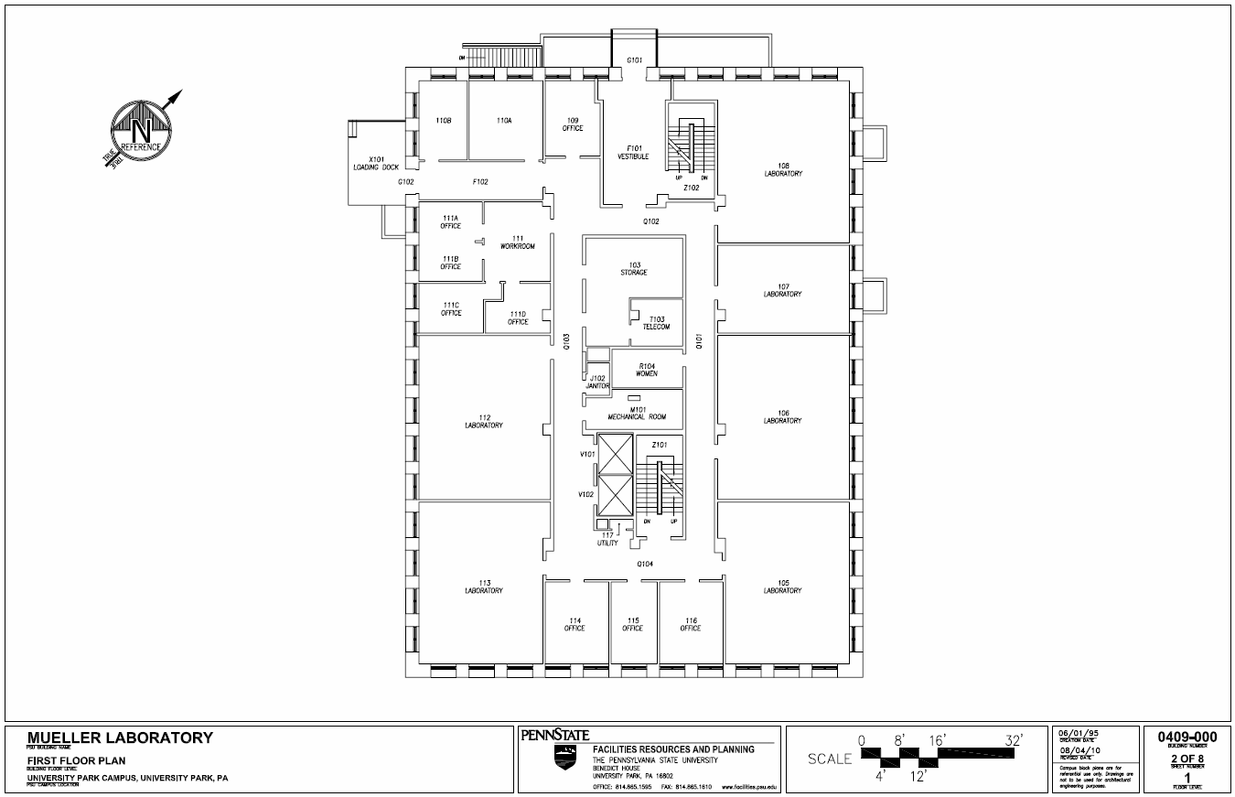

(Property of PSU OPP)



Existing Mueller Laboratory (Photo property of PSU OPP)



Rendering of completed Mueller Renovation (Photo property of PSU OPP)

Penn State collected bids for the project in fall of 2013.  Barton Malow was selected as the CM firm, with a team led by Scott Mull.  Starting in May of 2014, the renovation is schedule to be completed in August of 2015, in time for the start of that year's fall semester.  By its completion roughly 18 million dollars will have been spent on the renovation.



Many pieces of the building's renovation will make it more sustainable and reduce its impact on the environment.  The windows are being replaced with energy efficient glazing.  Connecting to campus chilled water will benefit from the economy of scale, saving energy.  Improved ventilation systems will both be more efficient and provides safer laboratory environments.  And improved electrical distribution will minimize loses.  Specific details of products being installed is being researched by the author at this time.

Though not an architectural marvel, once completed the renovated Mueller Laboratory will hopefully set an example to other labs across the university and even the nation as one of sustainability and energy efficiency. Techniques used to bring the building into the modern era can be applied to many similar structures. Penn State shows itself at the forefront of sustainability with its renovation of Mueller Laboratory.

Project Leader: Rob Bloom, PSU OPP

<http://www.opp.psu.edu/>

http://apps.opp.psu.edu/images/psu_opp_logo.gif

Stantec

<http://www.stantec.com/>



Barton Malow

<http://www.bartonmalow.com/>

