CHAPTER 1 – INTRODUCTION

1-1 Introduction
(1269 Reads)
This book will focus on the biology of small things, but what is microbiology? Microbiology could be defined as the study of organisms too small to be seen with the naked eye. Figure 1-14 shows the relative size of microbes compared to other living things. However, the recent discovery of bacteria of near 1 mm in size has made this definition somewhat inaccurate and in the grand tradition of science, a new definition is in order.

Figure 1-14 The relative size of microbes
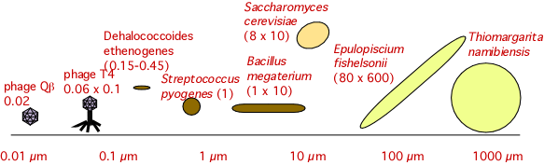
Microbes for being small, span a large range of sizes from the T4 virus virus that are 0.02 µm to giant bacteria larger than 700 µm.
We will consider microbiology to be the study of organisms that can exist as single cells, contain a nucleic acid genome for at least some part of their life cycle, and are capable of replicating that genome. This broad description encompasses an understandably large group of organisms including Figure 1-15. This definition would also include viruses, which microbiology texts traditionally discuss along with living organisms.

Figure 1-15 Some examples of the types of microbes present in the environment
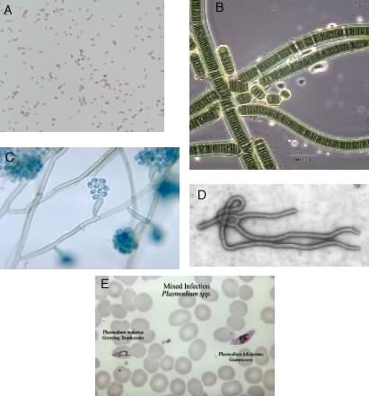
Many different organisms fall under the definition of microorganisms. Shown here are; A, the microorganism Escherichia coli; B, a photosynthetic cyanobacterium (Mike Clayton); C, a fungus (CDC); D, Ebola virus (CDC); E, the malaria parasite (a protozoan) (CDC).
Microbiology also involves a collection of techniques to study and manipulate these small creatures. Because of their size, special instruments and methods had to be developed to allow the performance of interpretable experiments on microorganisms. These methods are not restricted to microbes alone, but have also found utility in working with populations of cells from higher organisms.
With apologies to other small organisms, this book will mostly focus on bacteria (which we will also call microorganisms or microbes) and their impact on the rest of the biosphere. This can be weakly justified by the fact that bacteria have a major impact on the world around us and, because of their perceived importance, more research and knowledge has been accumulated about them.
Microorganisms are everywhere, but why are they worth learning about? The short answer is that they affect your life in many different ways. Before we begin our study of these creatures, we will first take a tour of some of their important habitats and point out why your existence depends upon them. We will then briefly explore the history of microbiology.

1-2 Microbes have a large impact on human health
(7463 Reads)
- Microbes cause many infectious diseases.
- Vaccines, antibiotics, and many other advances have lessened the impact of infectious disease in the developed world, but infectious disease in developing countries is high.
- New illnesses caused by microorganisms continue to emerge and known pathogens are becoming resistant to treatment.
If you ask the average person how microbes (or germs) impact their lives, they would immediately think of disease. Figure 1-16 shows a number of important pathogens. This is not a silly view, as pathogenic microorganisms have greatly affected human populations throughout our existence. In 1900 in the United States the infant mortality rate was near 50%, mostly due to childhood infectious disease and until about 1930, microbes were the major cause of death in humans. From today's perspective this is a horrendous statistic, over half of all infants did not make it to adulthood! With the advent of antibiotics, vaccines and better water sanitation, humanity has reduced the impact of pathogenic microbes in developed countries, but they will always remain an important social concern. The discipline of microbiology emerged from the study of these diseases, and most advances in treating various ailments has its roots in this relatively young science.

Figure 1-16 Some important pathogens
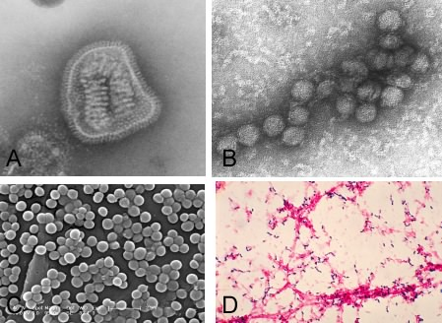
Many microbes cause disease in humans. Depicted here are several important pathogens that cause important illnesses. A, Influenza virus; B, West Nile Virus; C, Staphylococcus aureus; D, Streptococcus pneumoniae. Images courtesy of Dr. Erskine. L. Palmer; Dr. M. L. Martin (A), Cynthia Goldsmith (B), Janice Carr/ Jeff Hageman, M.H.S. (C), Dr. Mike Miller(D) all at the CDC.
While death from infectious disease in the U.S. has been greatly diminished, infection rates in developing nations remain unacceptably high. "Ancient" diseases continue to be a problem where nutrition and sanitation are poor, and emerging diseases such as Acquired Immunodeficiency Syndrome (AIDS) are even more dangerous for such populations. The Centers for Disease Control and Prevention (the U.S. government agency charged with protecting the health and safety of people) estimates that about 9% of adults between the ages of 18-49 in Sub-Saharan Africa are infected with HIV. Yet as you can see in Figure 1-13, AIDS is only one of a number of new diseases that have emerged. Many of these diseases have no known cure. Influenza and pneumonia are leading killers of the elderly even in the U. S. and other developed nations. Even the common cold causes illness and misery for almost everyone and drains the productivity of all nations. Many of the new diseases are viral in nature, making them notoriously difficult to treat.
Disease due to food-borne pathogens also remains a problem, largely because of consumption of improperly processed or stored foods. Understanding the sources of contamination and developing ways to limit the growth of pathogens in food is the job of food microbiologists.

Figure 1-13 Disease-causing microbes and infectious diseases recognized since 1973
Year | Microbe/disease | Type | Health problem
1973 | Rotavirus | Virus | Major cause of infantile diarrhea worldwide
1975 | Parvovirus B19 | Virus | Severe anemia
1976 | Cryptosporidium parvum | Parasite | Acute and chronic diarrhea
1977 | Ebola | Virus | Ebola hemorrhagic fever/uncontrolled bleeding and kidney failure
1977 | Legionella pneumophila | Bacteria | Legionnaireþs disease
1977 | Hanta virus | Virus | Hemorrhagic fever
1977 | Campylobacter jejuni | Bacteria | Short-term diarrhea
1980 | Human T-lymphotropic virus I (HTLV-I) | Virus | T-cell lymphoma-leukemial cancer of the blood
1981 | Toxic strains of Staphyloccus aureus | Bacteria | Toxic shock syndrome
1982 | Escherichia coli O157:H7 | Bacteria | Hemorrhagic colitis; hemolytic uremic syndrome
1982 | HTLV-II | Virus | Hairy cell leukemia
1982 | Borrelia burgdorferi | Bacteria | Lyme disease
1983 | Human immunodeficiency virus (HIV) | Virus | Acquired immune deficiency syndrome (AIDS)
1983 | Helicobacter pylori | Bacteria | Peptic ulcer disease
1985 | Entercytozoon bieneusi | Parasite | Persistent diarrhea
1986 | Cyclospora cayetanensis | Parasite | Persistent diarrhea
1988 | Human herpesvirus-6 (HHV-6) | Virus | Roseola subitum/skin rash
1988 | Hepatitis E | Virus | Liver infection; epidemic hepatitis
1989 | Ehrlichia chaffeensis | Bacteria | Human ehrlichiosis/influenza-like infection
1989 | Hepatitis C | Virus | Chronic liver infection
1991 | Guanarito virus | Virus | Venezuelan hemorrhagic fever
1991 | Encephalitozoon hellem | Parasite | Conjunctivitis
1991 | New species of Babesia | Parasite | Atypical lbabesiosis/infection with fever, chills and fatigue
1992 | Bartonella henselae | Bacteria | Catch scratch disease/bacillary angionmatosis
1993 | sin nombre virus | Virus | Adult respiratory distress syndrome
1993 | Encephalitozoon cuniculi | Virus | Infection with fever, chills and fatigue
1994 | Sabia virus | Virus | Brazilian hemorrhagic fever
1995 | HHV-8 | Virus | Associated with Kaposi sarcoma in AIDS patients
Source: WHO, The World Health Report 1996: 112
New infections continually appear. Having an available food source to grow on (humans) inevitably results in a microorganism that will take advantage. Some of these feeders will interfere with our own well being, causing disease.
Surprisingly, many diseases that were previously thought to have only behavioral or genetic components have been found to involve microorganisms. The clearest case is that of ulcers, which was long thought to be caused by stress and poor diet. However the causative agent is actually a bacterium, Helicobacter pylori, and many ulcers can be cured with appropriate antibiotics. Work on other non-infectious diseases such as heart disease, stroke and some autoimmune diseases also suggest a microbial component that triggers the illness.
Finally, some pathogenic microbes that had been "controlled" through the use of antibiotics are beginning to develop drug resistance and therefore reemerge as serious threats in the industrialized world as well as developing nations. Tuberculosis is an illness that was on the decline until the middle 80's. It has recently become more of a problem, partly due to drug resistance and partly due to a higher population of immunosuppressed individuals from the AIDS epidemic. Staphylococcus aureus strains are emerging that are resistant to many of the antibiotics that were previously effective against them. These staph infections are of great concern in hospital settings around the world. Understanding both familiar killers and new pathogens will require an understanding of their biology, and thus an understanding of the field of microbiology.

1-3 Microbes are often helpful, not harmful
(4951 Reads)
- Microbes form important mutualistic relationships with all sorts of organisms. Many of these relationships are important from a human perspective.
From the beginning of microbiology, significant resources have been spent to understand and fight disease-causing microorganisms. You may be surprised to learn that only a small faction of microbes are involved in disease; many other microbes actually enhance our well-being. The harmless microbes that live in our intestines and on our skin actually help us fight off disease. They actively antagonize other bacteria and take up space, preventing potential pathogens from gaining a foothold on our bodies. Indeed, like all large organisms, humans have entire communities of microorganisms in their digestive systems that contribute to their overall health. The microbial community in humans not only protects us from disease, but also provides needed vitamins, such as B₁₂.
Human health and nutrition also depends on healthy farm animals. Cows, sheep, horses and other ruminant animals utilize their microbial associates to degrade plant material into useful nutrients. Figure 1-1 shows the relationship between a cow and its microbes. Without these bacteria inside ruminants, growth on plant material would be impossible.

Figure 1-1 The cow as an example of a ruminant animal
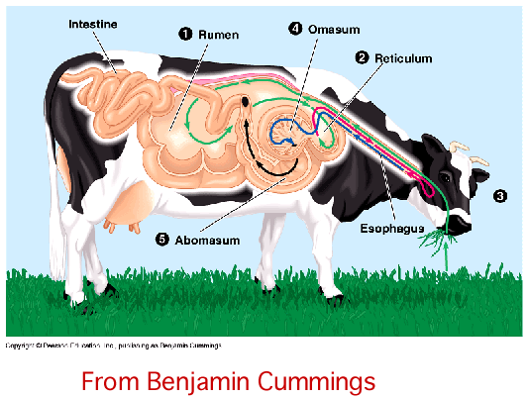
In contrast to humans ruminant animals have complex stomachs that harbor large numbers of microorganisms. These microbes degrade the plant stuff eaten by the animal into usable nutrients. Without the assistance of the microbes, ruminant animals would not be able to digest the food they eat.
Commercial crops are also central to human prosperity, and much of agriculture depends upon the activities of microbes. For example, an entire group of plants, the legumes, forms a cooperative relationship with certain bacteria. These bacteria convert nitrogen gas to ammonia for the plant, an important nutrient that is often limiting in the environment. Figure 1-17 shows a leguminous plant. Microbes also serve as small factories, producing valuable products such as cheese, yogurt, beer, wine, organic acids and many other items. In conclusion, while it is less apparent to us, the positive role of microbes in human health is at least as important as the negative impact of pathogens.

Figure 1-17 A leguminous plants

A picture of nodulated leguminous plants. In this case pea plants. Nodules are visible on the roots of the plants in the left of the picture. The plants on the right were not inoculated with nodulating bacteria. The image was taken from a publication by E. B. Fred, W. H. Wright and W. C. Frazier. 1921. Field Tests on the Inoculation of Canning Peas. Soil Science 11:479-491

1-4 Microbes have profound effects on the environment
(4056 Reads)
- Microbes make up the major portion of the biomass present on the Earth. Therefore, the nutrients they eat and the products they form greatly influence the environment.
- Cyanobacteria and algae in the oceans are responsible for most photosynthesis and are a major sink for carbon dioxide, a greenhouse gas.
- Microbes release nutrients from dead organisms, making them available to the rest of the ecosystem.
- Some microbes play a role in the production of energy, while other microbes interfere with energy production.
Whether measured by the number of organisms or by total mass, the vast majority of life on this planet is microscopic. These teaming multitudes profoundly influence the make-up and character of the environment in which we live . Presently, we know very little about the microbes that live in the world around us because less than 2 % of them can be grown in the laboratory. Understanding which microbes are in each ecological niche and what they are doing there is critical for our understanding of the world. Figure 1-2 shows some examples of environments where microbes are present
Microbes are the major actors in the synthesis and degradation of all sorts of important molecules in environments. Cyanobacteria and algae in the oceans are responsible for the majority of photosynthesis on Earth. They are the ultimate source of food for most ocean creatures (including whales) and replenish the world's oxygen supply. Cyanobacteria also use carbon dioxide to synthesize all of their biological molecules and thus remove it from the atmosphere. Since carbon dioxide is a major greenhouse gas, its removal by cyanobacteria affects the global carbon dioxide balance and may be an important mitigating factor in global warming.

Figure 1-2 A sampling of the different types of environments where microbe flourish

Microbes are capable of growing in a wide variety of environments. Bacteria will grow in frigid glaciers to boiling volcanic springs, dry sands to the open ocean. Figures from top left to bottom right, Bruce F. Molnia, J. R. Gill, Paul Carrara, Paul Carrara, Woods Hole Oceanographic Institute, USGS, Paul Carrara, Ann Gibbs, Paige Gill.
In all habitats, microorganisms make nutrients available for the future growth of other living things by degrading dead organisms. Microbes are also essential in treating the large volume of sewage and wastewater produced by metropolitan areas, recycling it into clean water that can be safely discharged into the environment. Less helpfully (from the view of most humans), termites contain microorganisms in their guts that assist in the digestion of wood, allowing the termites to extract nutrients from what would otherwise be indigestible. Understanding of these systems helps us to manage them responsibly and as we learn more we will become ever more effective stewards.
Energy is essential for our industrial society and microbes are important players in its production. A significant portion of natural gas comes from the past action of methanogens (methane-producing bacteria). Numerous bacteria are also capable of rapidly degrading oil in the presence of air and special precautions have to be taken during the drilling, transport and storage of oil to minimize their impact. In the future, microbes may find utility in the direct production of energy. For example, many landfills and sewage treatment plants capture the methane produced by methanogens to power turbines that produce electricity. Excess grain, crop waste and animal waste can be used as nutrients for microbes that ferment this biomass into methanol or ethanol. These biofuels are presently added to gasoline and thus decreasing pollution. They may one-day power fuel cells in our cars, causing little pollution and having water as their only emission.
Finally, We are increasingly taking advantage of the versatile appetite of bacteria to clean up environments that we have contaminated with crude oil, polycholrinated biphenyls (PCBs) and many other industrial wastes. This process is termed bioremediation and is a cheap and increasingly effective way of cleaning up pollution. Figure 1-18 shows before and after photographs of the clean up of the Exxon Valdez oil spill in Prince William Sound.

Figure 1-18 The Exxon Valdez oil spill

Microorganisms played an important role in removing many of the pollutants released during the Exxon Valdez oil spill in Prince William Sound. Interestingly, the microbes were not added to the site, but were native bacteria. A nutrient solution was sprayed onto the oil to encourage the growth of oil degrading microbes. This was one of the more successful treatments tried to clean up the oil, but no treatment removed all of the pollutants. Taken from http://www.battelle.org/environment/exxon-valdez.stm.

1-5 Studying microbes helps us to understand the world around us
(4049 Reads)
- Microbes are useful tools in research because of their rapid life cycle, their simple growth requirements, and their small size.
- Due to this simplicity, microbes have been essential in understanding core questions in biology.
- Attempts to classify microorganisms have lead to a classification system that divides all organisms into three domains of life, Archaea, Bacteria, and Eukarya.
- Microbes provide tools for use in molecular biology. These tools have allowed scientists to make rapid progress in investigating many types of microorgansims.
Microorganisms used in research have many useful properties. They will grow on simple, cheap medium and will often rise to large populations in a matter of 24 hours. It is easy to isolate their genomic material, manipulate it in the test tube and then place it back into the microbe. Due to their large populations it is possible to identify rare events and then, with the use of powerful selective techniques, isolate interesting bacterial cells and study them. These advantages have made it possible to test hypothesis rapidly . Using microbes scientists have expanded our knowledge about life. Below are a few examples.
Microorganisms have been indispensable instruments for unlocking the secrets of life. The molecular basis of heredity and how this is expressed as proteins was described through work on microorganisms . For an in-depth discussion on the molecular basis of heredity see the chapter on the Central Dogma. Due to the similarity of life at the molecular level, this understanding has helped us to learn about all organisms, including ourselves.
Some prokaryotes are capable of growing under unimaginably harsh conditions and define the extreme limits of where life can exist. Some species have been found growing at near 100 °C in hot springs and well above that temperature near deep-sea ocean vents Figure 1-19 depicts such a deep sea ocean vent. Others make their living at near 0 °C in freshwater lakes that are buried under the ice of Antarctica. The ability of microbes to live under such extreme conditions is forcing scientists to rethink the requirements necessary to support life. Many now believe it is entirely possible that Jupiter's moon Europa may harbor living communities in waters deep below its icy crust. What may the rest of the universe hold?

Figure 1-19 A deep sea ocean vent
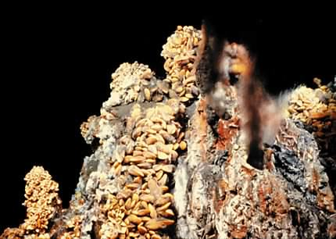
Ocean vents are common in areas of the sea floor that have volcanic activity. Water seeps into cracks on the floor and encounters magma. The water absorbs inorganic nutrients from the magma and is heated. The superheated water then flows out of the magma, sometimes quite forcefully, back into the ocean. This hot water contacts the cold ocean water, causing it to cool and release many of its inorganic contents. This cloud of inorganic compounds is highly reduced and can serve as a source of energy for microorganisms. These microbes serve as a primary producer for an entire food chain. The picture shows one type of ocean vent called a black smoker. Water coming out of the vent can be >300°C. Figure courtesy of Woods Hole Oceanic Institute.
Until recently, while we could study specific types of bacteria, we lacked a cohesive classification system, so that we could not readily predict the properties of one species based on the known properties of others. Visual appearance, which is the basis for classification of large organisms, simply does not work with many microbes because there are few distinguishing characteristics for comparison between species even under the microscope. However, analysis of their genetic material in the past 20 years has allowed such classification and spawned a revolution in our thinking about the evolution of bacteria and all other species. The emergence of a new system organizing life on Earth into three domains is attributable to this pioneering work with microorganisms.
The fruits of basic research on microbes has been used by scientists to understand microbial activity and therefore to shape our modern world. Human proteins, especially hormones like insulin and human growth factor, are now produced in bacteria using genetic engineering. Our understanding of the immune system was developed using microbes as tools. Microorganisms also play a role in treating disease and keeping people healthy. Many of the drugs available to treat infectious disease originate from bacteria and fungi.
One last recent role of microbes in informing us about our world has been the tools they provide for molecular biology. Enzymes purified from bacterial strains are useful as tools to perform many types of analyses. Such analyses allow us to determine the complete genome sequence of almost any organism and manipulate that DNA in useful ways. We now know the entire sequence of the human genome, with the exception of regions of repetitive DNA, and this will hopefully lead to medical practices and treatments that improve health. We also know the entire genome sequence of many important pathogens. Analysis of this data will eventually lead to an understanding of the function of critical enzymes in these microbes and the development of tailor-made drugs to stop them. The tools of molecular biology will also affect agriculture. For example, we now know the complete genome sequence of the plant Arabidopsis (a close relative of broccoli and cauliflower). This opens a new avenue to a better understanding of all plants and hopefully improvements in important crops.
Microbes have a profound impact on every facet of human life and everything around us. Pathogens harm us, yet other microbes protect us. Some microbes are pivotal in the growth of food crops, but others can kill the plants or spoil the produce. Bacteria and fungi eliminate the wastes produced in the environment, but also degrade things we would rather preserve. Clearly they effect many things we find important as humans. In the remainder of this chapter we take a look at how scientists came to be interested in microbes and follow a few important developments in the history of microbiology.

Quick Check 1.1 to 1.5

Choose/write the correct answer for each question, then click the Grade Exam button to see the correct answers

1. How do you suppose microbiology differs from biology?

2. Future epidemics in the United States are most likely going to come from which of the following sources (choose all that apply)?
A: | Newly emerging diseases
B: | Antibiotics
C: | Food borne pathogens
D: | Existing pathogens that have become resistant to current drugs.
E: | Bioterrorism

3. Humans would be better off if we could eliminate all bacteria living in and around our bodies.

4. Which of the following processes is performed primarily by microbes (as opposed to other organisms or by chemical processes) on Earth
A: | Photosynthesis
B: | Production of oil
C: | Production of natural gas
D: | Nitrogen fixation

5. Match the microbe with the disease it causes
Mycobacterium tuberculosis | 1. Anthrax
E. coli | 2. Pneumonia
Bacillus anthracis | 3. Whooping cough
Bordetella pertussis | 4. Diarrhea
Streptococcus pneumoniae | 5. Tuberculosis

