Chapter 2 – Cell Structure

2-1 Introduction
(3706 Reads)
Microorganisms typically face the world as single cells rather than as the multi-cellular assemblies of higher organisms. Each single cell must therefore contain all the structures necessary for managing its internal state and dealing with the outside environment. Not surprisingly, this evolutionary process results in the use of rather similar structures and processes to solve similar need in different microorganisms. However, prokaryotes have been on this earth for a long period of time and this has allowed them to differentiate into a dizzying number of different species. Eukaryotic microbes are not quite so diverse, but they still display a remarkable range of properties. The diversity of the microbial organisms also means that this survey of structures is not exhaustive. No one cell contains all the structures that we describe here, but we will explore the more common structures that have been observed by scientists in the past 150 years as show in Figure 2-1. A distinction in this discussion must be made between the two types of prokaryotes: the Archaea and their cousins, the Bacteria. We will initially focus on the Bacteria, since that is what we know the most about. Many of the structures we will examine are found in both the Bacteria and the Archaea, but there are some significant differences and these will be covered at the end of the chapter. Finally, we will talk about the features that are distinctive among the microbial eukaryotes.

Figure 2-1 The general bacterium
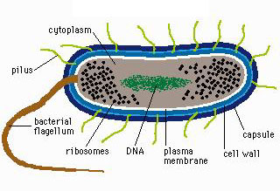
A cartoon of many of the common structure found on microorganisms. Not every microbe will have every one of these structures.
So how did scientists find out so much about such very small organisms? As you might guess, many techniques come into play when tackling a subject as complex as bacterial structure. electron microscopes have been important, of course, but so have genetics, molecular biology and biochemistry. Microscopes help scientists to visualize where these structures are located and how they are arranged spatially in the microbe. Bacterial genetics and molecular biology identify and analyze the genes necessary for the synthesis and regulation of these structures. Biochemistry permits the detailed examination of each part separately, with implications for its role in the living bacterium. The powerful combination of these disciplines has provided a deep understanding of how a bacterium is put together, but there is still much to learn.
This chapter on microbial structure is separated into two sections. In the first section, we describe the chemical nature of the types of molecules and polymers that are important in carrying out the business of biology. In the second section, we examine the functional units in the cell, describing how the various chemical structures in the cell interact to carry out important cellular functions. In this discussion we assume that the student has had an introductory chemistry course (at least in high school) and is somewhat familiar with chemical notation.
First and foremost, it is important to point out that there are some universal structures that all living cells contain. They are the basic building blocks of life: DNA, RNA, protein and cellular membranes. Most, but not all, bacteria also possess cell walls. Beyond these essentials, the frequency of the rest of the structures we mention here ranges in the bacterial world from quite common to very rare.

2-2 Sugars are common in the cell
(2288 Reads)
- Sugars store carbon and energy and are part of cellular structures
- Sugars in biological systems are 3 to 7 carbons and contain a carbonyl group
- Sugars can be monomers or polymers of 2, 3 or more sugars
Sugars serve three basic purposes in the cell: as carbon and energy sources, as reservoirs of carbon and energy, and as parts of cellular structures. Large amounts of energy can be extracted from sugars by processes referred to as catabolism, as discussed in Chapter 9. This may explain why many microorganisms show a preference for sugars if given a choice of energy sources. The term carbohydrate is often used to refer to them because their chemical formula can be broken down into [C(H₂O)]_{x} where x is any number greater than three.

Sugar Monomers
Single sugar molecules are typically 3 to 7 carbons long and are termed monosaccharides. Figure 2-2 shows that each carbon on the sugar molecule is decorated with a hydroxyl group (OH) except for one carbon that forms a carbonyl group If the carbonyl group is at the end of the molecule, it forms an aldehyde; if the carbonyl group is in the middle of the molecule, it forms a ketone as shown in Figure 2-2. All sugars can exist as linear molecules in solution and those greater than 5 carbons long can also circularize with the carbonyl group attacking a hydroxyl on one of the other carbons. The circular sugar contains 5 to 7 members in the ring with one of the members being oxygen. Glucose, fructose and ribose are some of the more common sugars found in the cell.

Figure 2-2 Common monosaccharides
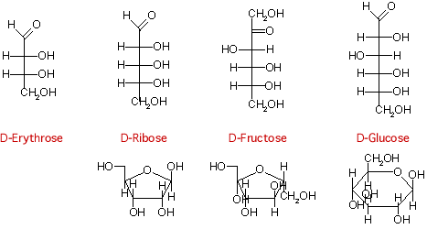
Structures of some important monosaccharides are shown. These will often serve as building blocks for major structures in the cell, such as the cell wall and the genome.

Sugar Polymers
Sugars will readily polymerize: the combination of two sugars is called a disaccharide, while the combination of three is called a trisaccharide, and polymers of greater than three sugars are referred to as polysaccharides. Sugars are connected by α or β linkages. If the hydrogen is pointing up, it is a α linkage, if the hydrogen is pointing down, it is a β linkage as shown in Figure 2-3. This distinction may seem trivial, but it greatly influences the properties of the molecule. (The name of the linkage further depends upon the orientation of the hydrogen on the lowest numbered carbon that forms the bond. The lowest numbered carbon is decided by the rules of organic chemistry, but this is really not important for our discussion. Just realize there is a set pattern of numbering for each organic molecule and this helps determines the α or β linkage.) For example, starch is made up of glucose linked by β-1,4 bonds. Starch is also water-soluble and can serve as a food source for many organisms. In contrast, cellulose, containing glucose linked by α-1,4 bonds, is insoluble in water and is not as readily degraded by most microbes. Polysaccharides might contain only one type of sugar monomer or a variety of different ones, sometimes in repeating units.

Figure 2-3 Common disaccharides, trisaccharides and polysaccharides
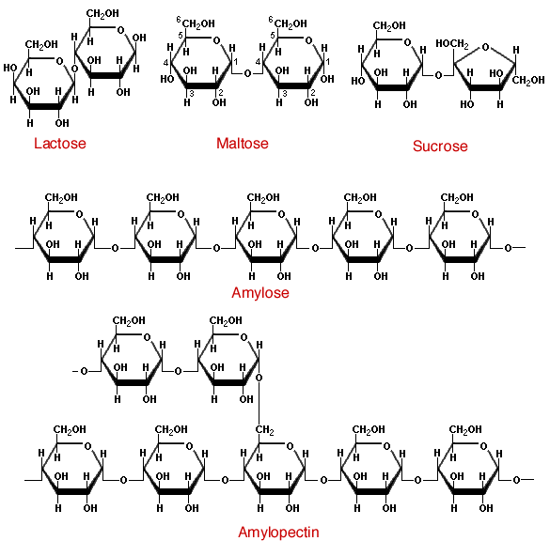
Sugars can be linked together to form more complex polymers. Lactose is a common sugar in milk, while maltose is found in many grains. Starch found in potatoes and other vegetables is a long polymer of glucose units. A common form of starch contains 20% amylose and 80% amylopectin.
Polymers of sugars can serve as storage products for the cell. The breakdown of sugar yields a huge amount of energy, which means that they are a terrific molecule to effectively store energy for later utilization. Starch and glycogen are two examples of sugar polymers that are used in this way. Polysaccharides also serve as structural components of many different molecules in the cell including nucleic acids and the cell wall.

2-3 Nucleic acids store information and process it
(2143 Reads)
- DNA and RNA are composed of two parts, the sugar phosphate backbone and nucleotide bases.
- The bases in DNA are purines (adenine and guanine) and pyrimidines (cytosine and thymine). RNA contains the same bases, except uracil is substituted for thymine and they contain an extra 5'-hydroxyl.
- DNA polymers can be thousands of base pairs long. RNA polymers are hundreds to thousands of bases long.
- RNA is single-stranded. DNA is double-stranded and forms a double helix in the cell.
- RNA molecules have significant secondary and tertiary structure that is important in their functions.
Deoxyribonucleic acid (DNA) and ribonucleic acid (RNA) are involved in information storage and processing. DNA serves as the cell's hereditary information, while RNA is involved in converting that information into functional products, such as proteins. RNA and DNA are long polymers of only 4 nucleotides: adenine, guanine, cytosine and thymine (or uracil for RNA). Figure 2-4 lists the structure of the five nucleotides found in nucleic acids.

Figure 2-4 The structure of nucleotides.
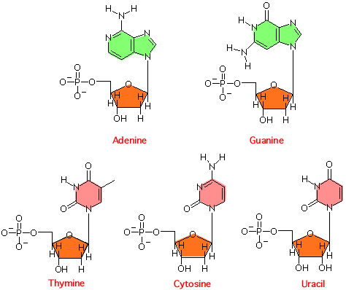
The sugar in this case is ribonucleic acid. The purines, adenosine (A) and guanine (G) and pyrimidines, uracil (U) and cytosine (C ) are found in ribonucleic acid. In this case the ribose sugar has two hydroyls on its ring at the 3' and 2' positions. Deoxyribonucleic is made up of A, G, C, and thymine (T) and the ribose sugar has only on hydroyl at the 3' position.
The nucleotide structure can be broken down into two parts: the sugar-phosphate backbone and the base. All nucleotides share the sugar-phosphate backbone, while the base distinguishes each type of nucleotide. Linking these monomer units together using a 5'-oxygen on the phosphate and the 3'-hydroxyl group on the sugar forms the nucleotide polymer as shown in Figure 2-5. Many thousands of DNA nucleotides are strung together to form genes and chromosomes.

Figure 2-5 A schematic of the nucleic acid polymer
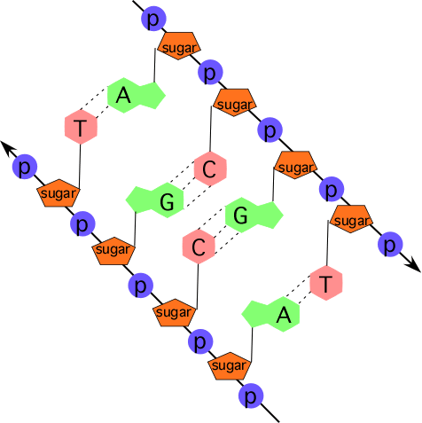
Each monomer is made of a sugar-phosphate backbone, from which a base protrudes. These can pair with a second strand forming the double helix. In this picture the bases of two strands are shown, pairing with a second complementary strand.
The bases of the four nucleotides are different, but there is also a pattern. Adenine (A) and guanine (G) are purines, and therefore have a distinctive two-ring structure; they differ in the chemical groups attached to the rings. Likewise, cytosine (C), thymine (T) and uracil (U) are all pyrimidines and share a single-ringed structure, but also differ in their attached groups. Not surprisingly, as these extra chemical groups distinguish the different purines and pyrimidines structurally, they are also responsible for their important functional differences as well.
The bases in a nucleic acid polymer are capable of forming hydrogen bonds with neighboring bases on a second strand of nucleic acid, a process termed a process termed base pairing. However, there are rules to this association. Adenine is capable of forming two hydrogen bonds with thymine (or uracil) and cytosine can base pair with guanine, forming three hydrogen bonds. Some of these bonds require the extra chemical groups mentioned above. If two single strands of nucleic acid have sequences that can base pair along the polymer (such sequences are sometimes said to complement), they will generate a long double-stranded polymer that has a staircase topology as shown in Figure 2-6. This structure is termed a double helix, since two strands form the molecule and it spirals around an axis in a regular pattern. Such a reaction between two complementary DNA strands is spontaneous: if you mix two complementary single strands of nucleic acid together in a test tube at a reasonable temperature, pH and salt concentration, they will find each other and anneal to form a double-stranded polymer.

Figure 2-6 The Double Helix
Note how the two nucleic acid strands spiral around each other in a regular repeating pattern. There are 10 bases per turn of the double helix. Bases pair with one another in the center of the helix cylinder and form what some have likened to a spiral staircase. The above figure can be rotated by clicking on the arrows.

Secondary and Tertiary DNA Structures
DNA almost always exists in cells as a double-stranded structure of complementing strands. It happens that this double-stranded form is rather stable, and it does not tolerate tight twists and turns. It is often assumed that the stability is due to the hydrogen bonding between the bases, but this is not the case (the bases would hydrogen bond just as well to water). Instead, it is largely due to the interaction between adjacent base pairs along the helix, which is termed base stacking. As a consequence, pieces of DNA typically form relatively straight structures where the only obvious difference from one piece to the next is the actual sequence of the nucleotides themselves. This ordered sequence is termed the primary structure of the DNA. The relative stiffness of the molecule means that the position of any base with respect to bases on either side, termed its secondary structure, is almost always predictable See Figure 2-7 for an example. Finally, the larger organization of the DNA strands with respect to each other, termed the tertiary structure, is also fairly similar in all DNA molecules. One implication is that proteins that want to distinguish between different DNA molecules must do so by reading different primary structure sequences by interacting with the outer surface of the base pairs.

Figure 2-7 A molecular model of the lac
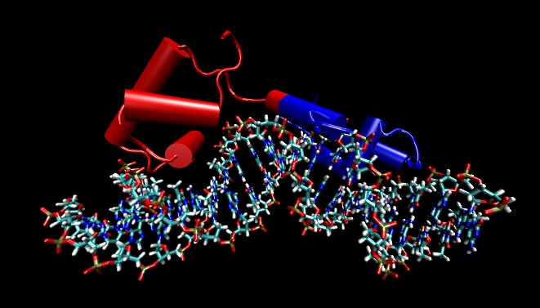
The repressor binding to its recognition sequence. The protein makes specific contacts with its recognition sequence on the DNA by reading the pattern of bases in the DNA.

Structures of RNA
In composition and therefore primary structure, RNA is similar to DNA, except that uracil (U) takes the place of thymine in the molecule and the ribose unit on each sugar contains a hydroxyl group. However, most RNA in cells exists as single-stranded molecules and not a complex of two different strands as with DNA. Now if complementary base sequences are present in an RNA molecule, it can fold back upon itself and base pair, so that many RNA molecules have at least some double-stranded regions. However, this bending and folding means that RNA molecules will typically have much more complicated tertiary structures than does DNA. Both the single-stranded loops and the double-stranded stems are critical for the function of most RNA molecules. Many are involved in creating physical structures, such as ribosomes, that are involved in processing information. The other general class of RNAs are messenger RNAs, which represent a version of the DNA primary structure that is suitable for translation into protein.

Quick check 2.1 to 2.3

Choose/write the correct answer for each question, then click the Grade Exam button to see the correct answers

1. Which of the following are true about the base composition of double-stranded DNA
A: | The total number of purines will be equal to the total number of pyrimidines.
B: | The total number of adenines will be equal to the total number of guanines.
C: | The total number of adenines will be equal to the total number of thymines.
D: | The total number of adenine and thymines will be equal to the total number of guanines and cytosines.

2. If RNA molecules all have a significant amount of double-stranded regions, reminiscent of those found in all DNA, then why do we say that RNA tends to have more complicated tertiary structures than does DNA?

3. The backbone of RNA is composed of..
A: | Adenine, thymine, cytosine and guanine
B: | ribose and phosphate
C: | bases, phosphate and ribose
D: | ribose

