IE497B : FAILURE MODE EFFECTS ANALYSIS (FMEA)

Using FMEA in Healthcare

Introduction
In our commercial sector, customers are placing increased demands on companies for high quality, reliable products. The increasing capabilities and functionality of many products are making it more difficult for manufacturers to maintain the quality and reliability. Traditionally, reliability has been achieved through extensive testing and use of techniques such as probabilistic reliability modeling. These are techniques done in the late stages of development. The challenge is to design in quality and reliability early in the development cycle.
Failure Modes and Effects Analysis (FMEA) is a methodology for analyzing potential reliability problems early in the development cycle where it is easier to take actions to overcome these issues, thereby enhancing reliability through design. FMEA is used to identify potential failure modes, determine their effect on the operation of the product, and identify actions to mitigate the failures. A crucial step is anticipating what might go wrong with a product. While anticipating every failure mode is not possible, the development team should formulate as extensive a list of potential failure modes as possible.
The early and consistent use of FMEAs in the design process allows the engineer to design out failures and produce reliable, safe, and customer pleasing products and services. FMEAs also capture historical information for use in future product improvement. FMEA has become a standard tool for both engineering design and process analysis. It has proven to be of great value in the early identification of potential reliability and safety issues. It is beginning to be used in the healthcare industry to improve services and products.

Types of FMEA's
There are several types of FMEAs, some are used much more often than others. FMEAs should always be performed for engineered systems whenever failures would mean potential harm or injury to the user of the end item being designed. The types of FMEA are:
- System - focuses on global system functions
- Design - focuses on components and subsystems
- Process - focuses on manufacturing and assembly processes
- Service - focuses on service functions
- Software - focuses on software functions

FMEA Usage
Historically, engineers and healthcare providers have done a good job of evaluating the functions and the form of products and processes in the design phase. They have not always done so well at designing in reliability and quality. Often the engineer (and now the healthcare provider) uses safety factors as a way of making sure that the design or treatment will work and protect the user against product or process failure. As described in a recent article:
"A large safety factor does not necessarily translate into a reliable product. Instead, it often leads to an over-designed product with reliability problems."
Failure Analysis Beats Murphy's Law
Mechanical Engineering , September 1993
FMEA's provide us with a tool that can assist in providing reliable, safe, and customer pleasing products and processes. Since FMEA help us to identify potential product or process failures, they can use it to:
- Develop product or process requirements that minimize the likelihood of those failures.
- Evaluate the requirements obtained from the customer or other participants in the design process to ensure that those requirements do not introduce potential failures.
- Identify design characteristics that contribute to failures and design them out of the system or at least minimize the resulting effects.
- Develop methods and procedures to develop and test the product/process to ensure that the failures have been successfully eliminated.
- Track and manage potential risks in the design. Tracking the risks contributes to the development of corporate memory and the success of future products as well.
- Ensure that any failures that could occur will not injure or seriously impact the customer of the product/process.

Benefits of FMEA
FMEA is designed to assist the engineer improve the quality and reliability of design. Properly used the FMEA provides the engineer several benefits. Among others, these benefits include:
- Improve product/process reliability and quality
- Increase customer satisfaction
- Early identification and elimination of potential product/process failure modes
- Prioritize product/process deficiencies
- Capture engineering/organization knowledge
- Emphasizes problem prevention
- Documents risk and actions taken to reduce risk
- Provide focus for improved testing and development
- Minimizes late changes and associated cost
- Catalyst for teamwork and idea exchange between functions

FMEA Timing
The FMEA is a living document. Throughout the product development cycle change and updates are made to the product and process. These changes can and often do introduce new failure modes. It is therefore important to review and/or update the FMEA when:
- A new product or process is being initiated (at the beginning of the cycle).
- Changes are made to the operating conditions the product or process is expected to function in.
- A change is made to either the product or process design. The product and process are inter-related. When the product design is changed the process is impacted and vice-versa.
- New regulations are instituted.
- Customer feedback indicates problems in the product or process.

FMEA Procedure
The process for conducting an FMEA is straightforward. The basic steps are outlined below.
- Describe the product/process and its function. An understanding of the product or process under consideration is important to have clearly articulated. This understanding simplifies the process of analysis by helping the engineer identify those product/process uses that fall within the intended function and which ones fall outside. It is important to consider both intentional and unintentional uses since product failure often ends in litigation, which can be costly and time consuming.
- Create a Block Diagram of the product or process. A block diagram of the product/process should be developed. This diagram shows major components or process steps as blocks connected together by lines that indicate how the components or steps are related. The diagram shows the logical relationships of components and establishes a structure around which the FMEA can be developed. Establish a Coding System to identify system elements. The block diagram should always be included with the FMEA form.
- Complete the header on the FMEA Form worksheet: Product/System, Subsys./Assy., Component, Design Lead, Prepared By, Date, Revision (letter or number), and Revision Date. Modify these headings as needed.
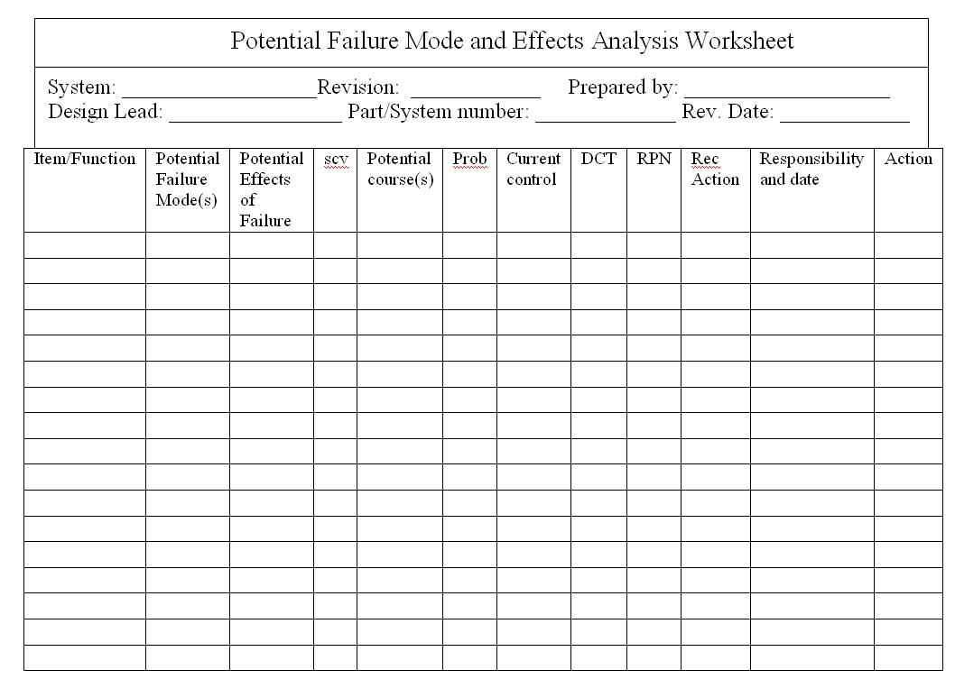
- Use the diagram prepared above to begin listing items or functions. If items are components, list them in a logical manner under their subsystem/assembly based on the block diagram.
- Identify Failure Modes. A failure mode is defined as the manner in which a component, subsystem, system, process, etc. could potentially fail to meet the design intent. Examples of potential failure modes include:
  - Corrosion
  - Hydrogen embrittlement
  - Electrical Short or Open
  - Torque Fatigue
  - Deformation
  - Cracking

- A failure mode in one component can serve as the cause of a failure mode in another component. Each failure should be listed in technical terms. Failure modes should be listed for function of each component or process step. At this point the failure mode should be identified whether or not the failure is likely to occur. Looking at similar products or processes and the failures that have been documented for them is an excellent starting point.
- Describe the effects of those failure modes. For each failure mode identified the engineer should determine what the ultimate effect will be. A failure effect is defined as the result of a failure mode on the function of the product/process as perceived by the customer. They should be described in terms of what the customer might see or experience should the identified failure mode occur. Keep in mind the internal as well as the external customer. Examples of failure effects include:
  - Injury to the user
  - Inoperability of the product or process
  - Improper appearance of the product or process
  - Odors
  - Degraded performance
  - Noise
Establish a numerical ranking for the severity of the effect. A common industry standard scale uses 1 to represent no effect and 10 to indicate very severe with failure affecting system operation and safety without warning. The intent of the ranking is to help the analyst determine whether a failure would be a minor nuisance or a catastrophic occurrence to the customer. This enables the engineer to prioritize the failures and address the real big issues first.
- Identify the causes for each failure mode. A failure cause is defined as a design weakness that may result in a failure. The potential causes for each failure mode should be identified and documented. The causes should be listed in technical terms and not in terms of symptoms. Examples of potential causes include:
  - Improper torque applied
  - Improper operating conditions
  - Contamination
  - Erroneous algorithms
  - Improper alignment
  - Excessive loading
  - Excessive voltage

- Enter the Probability factor. A numerical weight should be assigned to each cause that indicates how likely that cause is (probability of the cause occuring). A common industry standard scale uses 1 to represent not likely and 10 to indicate inevitable.
- Identify Current Controls (design or process). Current Controls (design or process) are the mechanisms that prevent the cause of the failure mode from occurring or which detect the failure before it reaches the Customer. The engineer should now identify testing, analysis, monitoring, and other techniques that can or have been used on the same or similar products/processes to detect failures. Each of these controls should be assessed to determine how well it is expected to identify or detect failure modes. After a new product or process has been in use previously undetected or unidentified failure modes may appear. The FMEA should then be updated and plans made to address those failures to eliminate them from the product/process.
- Determine the likelihood of Detection. Detection is an assessment of the likelihood that the Current Controls (design and process) will detect the Cause of the Failure Mode or the Failure Mode itself, thus preventing it from reaching the Customer. Based on the Current Controls, consider the likelihood of Detection using the following table for guidance.
- Review Risk Priority Numbers (RPN). The Risk Priority Number is a mathematical product of the numerical Severity, Probability, and Detection ratings:
RPN = (Severity) x (Probability) x (Detection)
The RPN is used to prioritize items than require additional quality planning or action.
- Determine Recommended Action(s) to address potential failures that have a high RPN. These actions could include specific inspection, testing or quality procedures; selection of different components or materials; de-rating; limiting environmental stresses or operating range; redesign of the item to avoid the failure mode; monitoring mechanisms; performing preventative maintenance; and inclusion of back-up systems or redundancy.
- Assign Responsibility and a Target Completion Date for these actions. This makes responsibility clear-cut and facilitates tracking.
- Indicate Actions Taken. After these actions have been taken, re-assess the severity, probability and detection and review the revised RPN's. Are any further actions required?
- Update the FMEA as the design or process changes, the assessment changes or new information becomes known.

An Example of FMEA in Healthcare

Introduction
For the Calgary Health Region (CHR), patient safety was brought to the forefront in the spring of 2004, when there were two critical incidents that resulted in the death of two patients receiving CRRT in two different ICUs of the CHR (ISMP alert March 25, 2004). Here is a brief description of the incidents from the External Patient Safety Review (June 2004):
" An 83-year-old woman who was a patient in the cardio-vascular care unit at the Foothills Medical Center (FMC) site of the CHR died suddenly in the presence of her physician and members of her family. She was alert and oriented at the time and her condition, while very serious, did not seem to indicate reasons for immediate concern. Her unexpected death was devastating for her family and extremely distressing for all those involved in her care. An ICU physician suspected the cause - the composition of dialysate solution being used to treat her kidney failure. This was quickly confirmed and 30 bags of the solution made in the same batch were removed from patient care areas, undoubtedly preventing the deaths of other patients. An analysis of the other bags from that batch as well as a systematic review of patient records identified a second patient whose death, one week earlier, was likely caused by the same set of circumstances. This was not suspected at the time of death due to the patient's serious condition."
Upon further investigation, it was determined that in February 2004, pharmacy technicians in the central production facility of the CHR pharmacy department prepared a dialysate solution for patients receiving CRRT. During the process, KCL was inadvertently added to the dialysate bags instead of sodium chloride (NaCl) solution. It is believed that these incorrectly prepared solutions were used in the dialysis of the two patients who died (External Patient Safety Review, CHR June 2004).
The CHR publicly disclosed the facts and initiated an external patient safety review. The Department of Critical Care Medicine (DCCM) also undertook a review of the process for ordering and administering intravenous, high-concentration KCl and KPO4, using the HFMEA tool developed by DeRosier, Joseph et al. (2002). The focus of this article is to describe the application of the tool with respect to reviewing the processes involved in ordering and administering intravenous, high-concentration KCl and KPO4, thereby allowing the DCCM to proactively identify hazards that may exist and establish a safer process.

Background
The DCCM has been engaged in ongoing quality improvement and patient safety initiatives both formally and informally for over 10 years (Esmail et al. 2005). At present, the region includes three adult acute care teaching hospitals and one pediatric hospital: Foothills Medical Centre (FMC), Peter Lougheed Center (PLC), Rockyview General Hospital (RGH) and the Alberta Children's Hospital. The Department of Critical Care Medicine oversees four adult intensive care units:
- A 24-bed Multisystem ICU (FMC)
- A 14-bed Cardiovascular ICU (FMC)
- A 12-bed Multisystem ICUs (PLC)
- A 10-bed Multisystem ICUs (RGH)

HFMEA vs Failure Mode and Effect Analysis (FMEA)
In the past, medicine used a human error approach which identified the individual as the cause of the adverse event. We now recognize that errors are caused by system or process failures (McNally et al. 1997). FMEA was developed for use by the United States military and is utilized by the National Aeronautics and Space Administration (NASA), to predict and evaluate potential failures and unrecognized hazards and to proactively identify steps in a process that could help reduce or eliminate a failure from occurring (Reiling et al. 2003). FMEA focuses on the system within an environment and uses a multidisciplinary team to evaluate a process from a quality improvement perspective. The Joint Commission for Accreditation of Healthcare Organizations (JCAHO) in the US has recommended that healthcare institutions conduct proactive risk management activities that identify and predict system weaknesses and adopt changes to minimize patient harm (Adachi et al. 2001).
In 2001 the Veteran's Administration (VA) National Centre for Patient Safety (NCPS) specifically designed the HFMEA tool for risk assessment in the healthcare field.
The HFMEA tool was formed by combining industry's FMEA model with the U.S. Food and Drug Administration's Hazard Analysis and Critical Control Point (HACCP) tool together with components from the VA's root cause analysis (RCA) process. HACCP was developed to protect food from chemical and biological contamination and physical hazards. The HACCP system uses seven steps: (1) conduct a hazard analysis, (2) identify critical control points, (3) establish critical limits, (4) establish monitoring procedures, (5) establish corrective actions, (6) establish verification procedures, and (7) establish record-keeping and documentation procedures (Center for Food Safety and Applied Nutrition, 1997). It uses questions to probe for food system vulnerabilities as well as a decision tree to identify critical control points. The decision tree concept was adapted by the VA for the HFMEA tool. The HFMEA tool has been subsequently recognized in the White Paper prepared by the American Society for Healthcare Risk Management (ASHRM). In an effort to globally share the merits of this process, a video, instructional CD and worksheets on the use and application of HFMEA has been sent to every hospital CEO in the US to be shared with individuals and risk managers responsible for patient safety (American Society for Health Risk Management 2002).

HFMEA Tool

There are five steps in the HFMEA tool. Step one is to define the topic; step two is to assemble the team; step three requires the development of a process map for the topic and consecutively numbering each step and substeps of that process; step four is to conduct the hazard analysis. This step involves four processes: the identification of failure modes, identification of the causes of these failure modes, scoring each failure mode using the Hazard Scoring Matrix, and working through the Decision Tree Analysis. The final step is to develop actions and outcomes. The next section will describe how the DCCM's Patient Safety and Adverse Events team (PSAT) worked through each step of the HFMEA tool to review the process of ordering process of ordering intravenous, high-concentration KCl and KPO4.

HFMEA - Step One
Step one is to define the HFMEA topic. The topic is usually a process that has high vulnerabilities and potential for impacting patient safety. It is important in a HFMEA analysis to define boundaries and limit the scope of the topic being reviewed.
Following the two previously mentioned critical incidents, two reviews were conducted in the CHR. The first was an internal review and was conducted by the Patient Safety Task Force, and the second was considered external and performed by the External Patient Safety Review Committee (June 2004). During the same time, in response to the tragic events from March 2004, disparate and poorly coordinated changes in policy regarding the storage and use of highly concentrated potassium were initiated within the regional ICUs. The department's ICU executive council determined the need to undertake a review of the process for the general handling of intravenous, high-concentration KCl and KPO4 prior to reviewing the process of preparing CRRT bags for dialysis. It was understood that some of the steps in this process would overlap with the CRRT process.

HFMEA - Step Two
Step two in the HFMEA tool is to assemble a team. The team should include six to eight multidisciplinary members who are involved in the process being analyzed and are to some degree considered "subject matter" experts.
The department's PSAT was assigned this task. The team was co-led by an intensivist and the department's quality improvement and patient safety consultant. The team was multidisciplinary, with two intensivists, three respiratory therapists, two nursing educators, two frontline nursing staff from each hospital site and two pharmacists. The team had been previously working on chart reviews of adverse events using the IHI trigger tool methodology (Rozich et al. 2003) and staff education with respect to incidents and incident reporting. The team met every other week over a two-month period (April and May 2004).

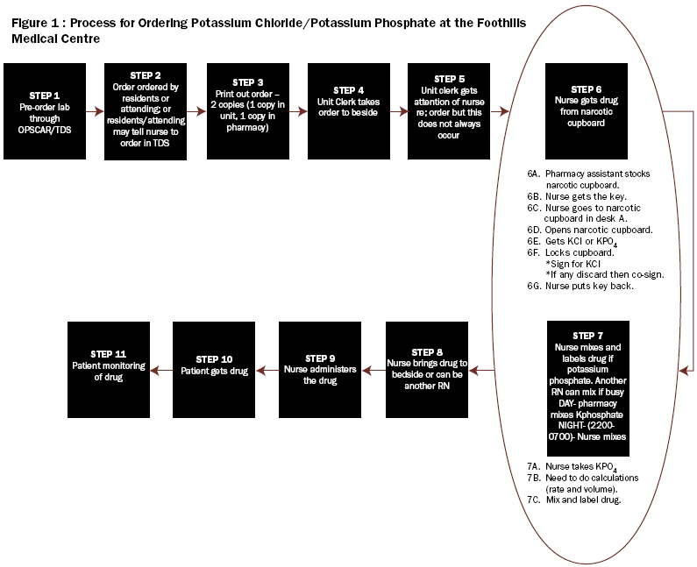

HFMEA - Step Three

Step three of the HFMEA tool requires the development of a process map for the topic and consecutively numbering each step and substeps of that process. If the process is too complex, a specific area within the overall process can be focused upon. The team identified 11 steps in the process of ordering and administering KCl and KPO4 (Figure 1). After reviewing these 11 steps, the team focused on two critical steps: obtaining the drug (step #6) and mixing the drug (step #7) and then identified the substeps for each of these two HFMEA steps (Figure 2). Site visits to review where KCL and KPO4 were stored and conversations with frontline staff in the units to verify the process were also conducted.

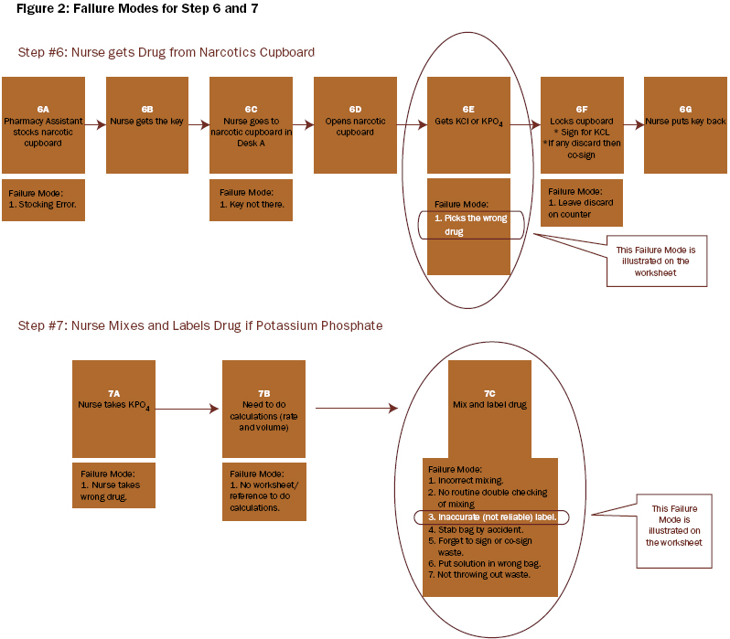

HFMEA -Step Four

In step four of the HFMEA tool, the area of focus is further narrowed using the following four processes: identification of failure modes, identification of the causes of these failure modes, scoring each failure mode using the Hazard Scoring Matrix, and working through the Decision Tree Analysis (DeRosier et al. 2002). The team identified the failure modes for steps #6 and #7 (Figure 2). The failure modes that received the highest hazards scores were: nurse selecting the wrong drug, distractions when mixing and inaccurate, or incomplete labels. Using the HFMEA decision tree analysis, the team worked through each hazard to determine if it needed further action.

HFMEA - Step Five
In step five of the HFMEA tool, actions are developed. Actions to address the identified hazards need to focus on root causes or contributing factors and need to be specific and concrete. Frontline staff involved directly in the process need to review them. Actions can then be tested prior to implementation using the Improvement Model methodology that includes testing changes using the Plan-Do-Study-Act (PDSA) cycle (Langley et al. 1996). Outcomes must be measurable, with a defined sampling strategy, set timeframe for measurement and with a realistic well-articulated goal.
Eleven recommendations were developed based on this analysis (Appendix I). These recommendations were placed into two categories, general and ICU-specific, and subsequently presented to the ICU executive council in July 2004. These recommendations addressed how KCl and KPO4 are to be stored and who, where, and how the drugs are to be mixed. These recommendations also focused on the identification of look-alike and sound-alike products based on human factor principles (Gosbee et al. 2002 and Wickens et al. 2004). Key recommendations were summarized into an action plan with delegated responsibility and timelines for implementation (Figure 3).

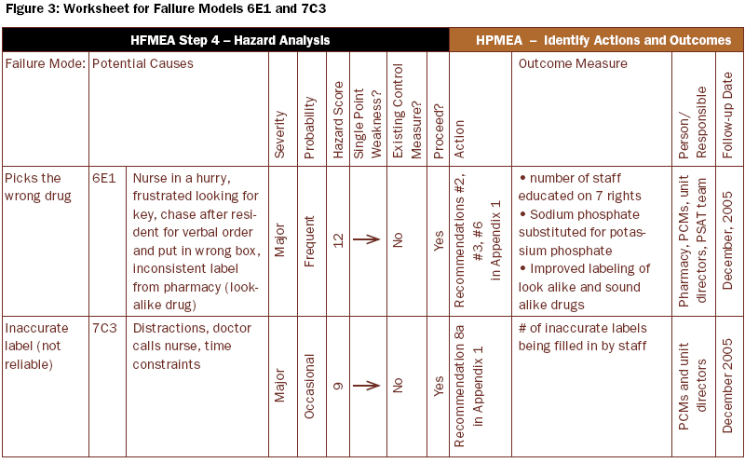

Implementation of the recommendations has proven to be more difficult than the HFMEA process itself. Once the recommendations were presented and approved at ICU executive council, those that were key ICU-specific recommendations were primarily delegated to pharmacy, unit patient care managers (PCMs) and unit directors and PSAT for implementation with specified timelines. For example, for recommendation #2, a "safety snippet" on the seven rights of drug administration was developed by a PSAT member and posted on the internal DCCM website to educate staff. Recommendations that had a broader regional impact were shared with the region's working group on high-risk medications who were developing a regional policy on KCl. The region is also in the process of developing standard labels for look-alike and sound-alike drugs.

Discussion

Team Lessons Learned
HFMEA was well recognized by the PSAT and it provided a solid framework for the step-by-step analysis of potassium ordering and administration. The team members were unaware of the numerous steps involved in administrating this medication and it became obvious that there were many opportunities for errors to occur. HFMEA enabled the team to prioritize the critical items of a complex process and took the subjectivity out of the analysis.
The multidisciplinary structure of PSAT allowed members to identify each step from their own professional practice perspective. The PSAT composition also generated diverse ideas when brainstorming actions and allowed for good discussion and deliberation, which ultimately promoted team building.
HFMEA was an easy tool to use by all members of the team. It made the approach to a very complicated process relatively straightforward. Using the HFMEA tool, the two leaders were able to focus the team on the specific components of the tool. The tool enabled the team to develop a structured outline of the goals that needed to be accomplished at each meeting. The team has also used this tool to analyze the hazards of the process for preparing CRRT bags for dialysis patients in the ICU.
Although the work of the PSAT was extremely valuable for the department, it was also time consuming. It would be appropriate to conduct a HFMEA analysis on one or two high-priority topics per year as has been recommended by the Joint Commission on Accreditation of Health Care Organizations in the United States (Adachi et al. 2001).

Pharmacy Lessons Learned
The dialysate manufacturing error came as a harsh reminder to the CHR's pharmacy department of its need for structured policies and procedures for error avoidance. This error occurred despite existing safety procedures that including four double checks by pharmacists. The risks associated with intravenous potassium came to the forefront of the pharmacy department's focus and there was a heightened awareness of pharmacy's role in patient safety.
Since 2002, intravenous high concentration KCL vials have not been available in most patient care areas in the CHR. Premixed KCL bags are available and any special bags not commercially available are to be mixed in the pharmacy department. These policies are based on the ISMP Canada recommendations (2002) and also reiterated in the PSAT recommendations. Prior to the incidents, intravenous potassium vials were available in the night dispensary for use while the pharmacy was closed; these have now been replaced by premixed bags. The only vials of intravenous potassium available outside the pharmacy department include a small supply of KCl vials kept in narcotic cupboards of critical care and dialysis units. These vials are to be used for special CRRT solutions only.
Before the dialysate manufacturing error occurred, intra-venous potassium vials were stored on the regular drug shelves within the pharmacy department. Since the error, all intra-venous potassium vials are stored in a separate, locked area within the pharmacy. All intravenous potassium vials and minibags are now labelled with a warning sticker to further distinguish them, as per the recommendation from ISMP Canada (ISMP alert 2002).
Additionally, drug identification numbers have been added to the manufacturing worksheets used by pharmacy technicians in the sterile product preparation area. This adds redundancy through checking of the procedure for sterile products, including dialysate. Batches of dialysate are now quarantined until potassium levels in each batch are confirmed to be zero by laboratory testing.
By changing preparation, manufacturing, labeling and storage procedures for intravenous potassium products, the risk of error has been substantially reduced.

Conclusion
This article described the use of the HFMEA tool developed by the VA and its application in the process of ordering and administrating intravenous high-concentration KCL and KPO4. Eleven recommendations resulted from this analysis. The ICU-specific recommendations that did not incur costs were implemented expeditiously. General recommendations, which were not under the purview of the DCCM, were shared with CHR's Regional Patient Safety Committee, which has since developed a regional policy on KCl.
In addition to this work, the knowledge and understanding gained from the application of the HFMEA tool by DCCM's PSAT will be shared with the Regional Patient Safety Transport working group reviewing patient transport between hospitals. This group has been formed based on recommendations from the External Patient Safety Review (June 2004). The Quality, Safety & Health Information Portfolio of the region is also in the process of determining the use or modification of this tool to proactively identify hazards in the system.
More importantly, the two critical incidents served as triggers that brought patient safety to the forefront for the CHR and the DCCM. Numerous changes and initiatives based on the recommendations from the internal and external reviews have been initiated or are underway with an attempt to transform the culture of the organization to one with a much greater awareness of hazard identification, incident and near miss reporting and patient safety.

Appendix 1: Recommendations
General/ICU
1. Use premixed solutions for high-risk drugs as much as possible.
- Pharmacy premixes the high-risk medications.
- Unusual or nonstandard doses not be mixed or administered, further, minimizing the need to mix potassium solutions.
General/ICU
2. Education, to re-emphasize the 5 (7) RIGHTS of drug administration: Right patient, right drug, right dose, right route, and right time, and,
Right reason and right documentation.
- Encourage a culture of double-checking of orders with physicians, when high-risk drugs are ordered.
- Promote the identification of high-risk drugs.
General
3. Concentrated potassium solutions (high-concentrated vials) are removed from ward stock and the night pharmacy.
- Sodium phosphate is substituted for potassium phosphate.
- Monobasic potassium phosphate solution, when needed, is the only solution used.
ICU
- With respect to CRRT, concentrated solutions are CRRT-specific or patient-specific medications. Only a small supply (4-6 vials) is available, after pharmacy has closed, for CRRT use only.
ICU
4a. Better identification and storage of the various minibags, with large colour-coded labels used.
- Storage and medication areas are reorganized to separate bins, make them more distinct and placed at an appropriate and safe working level.
- The bins for the respective potassium concentrations are colour coded (i.e., with auxiliary fluorescent labels).
- Minibags be labelled and distributed from pharmacy.
- Pharmacy participates in this reorganization and takes ownership of the long-term organization of medication areas.
- Have a magnifying glass available in all medication areas.
ICU
4b. Reduce the range of premixed potassium solutions available.
- Restrict access and use of 40-mmol KCL minibags to only ICU patients, whose potassium is being replaced, per ICU potassium protocol. Provided that recommendation 4a is implemented.
- Use multiples of premixed bags for patients whose potassium is not being replaced per protocol.
- Goal should be to standardize the ordering of potassium with universal doses or protocol, concentrations and set infusion rates.
General/ICU
4c. If possible, use oral potassium supplements in lieu of intravenous solutions.
ICU
5a. In the FMC site, the "A" medication area is moved away from the unit clerk's desk. At the RGH site, medication area moved or renovated to decrease noise and distractions.
General/ICU
5b. Educate and encourage a do not disturb policy when medications are being mixed.
General/ICU
6. Look-alike and sound-alike drugs are highlighted better.
- Use the same warning labels, consistently, throughout the region.
- "Medication alert" labels be replaced with more specific labels stating either look- alike, sound-alike, different doses or routes.
ICU
7. When boluses of potassium are being given the orders and medication be double-checked and charted in QS. This should include patients receiving boluses of 40 mmols or greater or when the ICU K protocol is used.
General/ICU
8a. When medications are mixed in the ICU or on the ward, proper labelling is to include patient name, drug, concentration, date/time and who mixed the medication.
ICU
8b. A standardized protocol is developed and implemented for the administration and monitoring of potassium replacement in severe life threatening hypokalemia.
General/ICU
9a. Clear and simple instructions for mixing a solution are included in the region's intravenous therapy manual.
- Goal is to minimize calculations and errors.
- Consideration is given to use of calculation grids in the instruction manuals.
- Revise the pharmacy information section on the internal ICU website, making information more easily available.
General
10. Consider using satellite pharmacies in areas where high-risk drugs are used.
ICU
9b. Use a "keypad box" for the narcotics key at the FMC site. (Currently used at the PLC and RGH.)
General
11. Immediate changes to the TDS order sets are made.
- Reduce the options; i.e., solutions, concentrations, volumes and rates available for ordering potassium.
- Promote the cultural changes necessary to reduce the use of verbal orders for all high-risk drugs. General/ICU
- Introduce barriers when ordering potassium to prevent duplicated or multiple potassium orders for an individual patient.
- Implement KCL protocols with appropriate inclusion and exclusion criteria, time limits or termination points are developed for non-ICU patients. Include in the protocol links to serum creatinine and previous potassium doses (similar to current Coumadin order sets in TDS).
- Tables showing estimated potassium deficits and rate of replacement are included in the protocols.

